# REQUEST FOR PROPOSALS

Procurement of Consulting Services



**Royal Government of Bhutan**

**Ministry of Finance**

April 2009

**(Revised July 2015)**

**Procurement reference : NLCS/PROC-13/Advt. Consult/2017-18/**

**1071 Date 28/03/2018.**

**Name of the Works/Prihect : Providing Consulting Services for**

**Development of e-Sakor Portal, NLCS.**

**Last date of Bid submission : 27th April, 2018**

**Date and time of bid opening : On 27th April, 2018 at 11.30AM**

**Sell of document : 29th March, 2018 from Procurement Section or can be downloaded from website**

**www.nlcs.gov.bt**

*March 2018*

**Preface**

This Standard Request for Proposals (SRFP) is based on the 2009 Procurement Rules and Regulations of the Royal Government of Bhutan. The SRFP will be using quality- and cost-based selection (QCBS)

To obtain further information on procurement you may contact:

Public Procurement Policy Division

Ministry of Finance

Royal Government of Bhutan

**REQUEST FOR PROPOSALS**

**RFP # [RFP02]**

***Project Name* [*Development of e-Sakor Portal*]**

***Procuring Agency* [National Land Commission]**

***Title of Consulting Services* [Software Development]**

# Table of Contents

**Section 1**: Letter of Invitation 1

Section 2: Instructions to Consultants 1

**Section 3:** Technical Proposal - Standard Forms 20

**Section 4:**  Financial Proposal - Standard Forms 36

**Section 5:** Terms of Reference (TOR) 46

**Section 6:** Standard Forms of Contract 69

Consulting Services: Lump-Sum Contract 69

**Preface** 71

I. Form of Contract 73

II. General Conditions of Contract 75

III. Special Conditions of Contract 89

IV. Appendices 97

# Section 1: Letter of Invitation

**Not Applicable**

# Section 2: Instructions to Consultants

|  |  |  |
| --- | --- | --- |
| **DeDefinitions:**  **D** | **(a) Consultant:** An individual or a legal entity entering into a Contract to provide the required Consulting Services.  **(b) Consulting Services:** Expert services of a professional and/or intellectual nature, provided by the Consultant based on specialized expertise and skills, in areas including, but not limited to, preparing and implementing projects, conducting training, providing technical assistance, conducting research and analysis, preparing designs, supervising the execution of construction and other works, undertaking studies, advising Procuring Agencies, building capacity, preparing tender documents, supervising procurement, and others.  **(c) Contract:** The formal agreement in writing, including the General Conditions (GC), the Special Conditions (SC), and the Appendices, entered into between the Procuring Agency and the Consultant, on acceptable terms and conditions and which are in compliance with all the relevant provisions of the laws of the Kingdom of Bhutan, for the provision of the required Consulting Services.  **(d) Data Sheet:** Such part of the Instructions to Consultants used to reflect specific assignment conditions.  **(e) Day:** A calendar day.  **(f) Government:** Royal Government of Bhutan (RGoB).  **(g) Instructions to Consultants(Section 2 of the RFP):** The document which provides the shortlisted Consultants with all the information needed to prepare their Proposals.  **(h) In Writing:** Communicated in written form (eg by mail, electronic mail, fax, telex) with proof of receipt.  **(i) LOI (Section 1 of the RFP):** The Letter of Invitation being sent by the Procuring Agency to the shortlisted Consultants.  **(j) Personnel:** Professional and support staff provided by the Consultant or by any Sub-Consultant and assigned to perform the Services or any part thereof; “Foreign Personnel” means such professional and support staff who at the time of being so provided have their domicile outside Bhutan; “Local Personnel” means such professional and support staff who at the time of being so provided have their domicile inside Bhutan.  **(k) Procuring Agency:** RGoB agency with which the selected Consultant signs the Contract for the Services.  **(l) Proposal:** The Technical Proposal and the Financial Proposal.  **(m) RFP:** The Request for Proposal to be prepared by the Procuring Agency for the selection of Consultants, based on the SRFP.  **(n) SRFP:** The Standard Request for Proposals, which must be used by the Procuring Agency as a guide for the preparation of the RFP.  **(o) Services:** The work to be performed by the Consultant pursuant to the Contract.  **(p) Sub-Consultant:** Any person or entity to whom/which the Consultant subcontracts any part of the Services.  **(q) Terms of Reference (TOR):** The document included in the RFP as Section 5 which defines the objectives, goals, scope of work, activities, tasks, responsibilities of the Procuring Agency and the Consultant, required outputs and results of the assignment, as well as background information (including a list of existing relevant studies and basic data) to facilitate the Consultants’ preparation of their proposals. | |
| **1 Introduction** | | * 1. The Procuring Agency named in the Data Sheet will select a consulting firm/organisation (the Consultant) from those listed in the Letter of Invitation[1] in accordance with the method of selection specified in the Data Sheet.   2. The shortlisted Consultants are invited to submit a Technical Proposal and a Financial Proposal, for Consulting Services required for the assignment named in the Data Sheet. The Proposal will be the basis for contract negotiations and ultimately for a signed Contract with the selected Consultant.   3. Consultants should familiarize themselves with local conditions and take these into account in preparing their Proposals. To obtain first-hand information on the assignment and local conditions, Consultants are encouraged to attend a pre-proposal meeting if one is specified in the Data Sheet. Attending the pre-proposal meeting is optional. Consultants should contact the Procuring Agency’s representative named in the Data Sheet to obtain additional information on the pre-proposal meeting. Consultants should ensure that this official is advised of the proposed attendance at the meeting in adequate time to allow them to make appropriate arrangements.   4. The Procuring Agency will provide in timely fashion and at no cost to the Consultant the inputs and facilities specified in the Data Sheet, assist the Consultant in obtaining licenses and permits needed to carry out the Services, and make available relevant project data and reports.   5. Consultants shall bear all costs associated with the preparation and submission of their proposals and contract negotiation. The Procuring Agency is not bound to accept any proposal, and reserves the right to annul the selection process at any time prior to Contract award, without thereby incurring any liability to the Consultants. |
| 1. **Conflict**   **of**  **Interest** | | 2.1The Procuring Agency and the RGoB requires that Consultants provide professional, objective and impartial advice, and at all times hold the Procuring Agency’s interests paramount, strictly avoid conflicts with other assignments or their own corporate interests, and act without any consideration for future work. Without limitation on the generality of the foregoing Consultants, and any of their affiliates, shall be considered to have a conflict of interest, and shall not be recruited, under any of the circumstances set forth below:   1. Conflicting Activities:   A firm that has been engaged by the Procuring Agency to provide goods, works or services other than Consulting Services for a project, and any of its affiliates, shall be disqualified from providing Consulting Services related to those goods, works or services. A firm hired to provide Consulting Services for the preparation or implementation of a project, and any of its affiliates, shall be disqualified from subsequently providing goods or works or services resulting from or directly related to the firm’s Consulting Services for such preparation or implementation.  (b) Conflicting Assignments:  A Consultant, including its Sub-Consultants, affiliates and the Personnel of any of the foregoing, shall not be hired for any assignment that, by its nature, may be in conflict with another assignment of the Consultant to be executed for the same or for another Procuring Agency. Similarly, a Consultant hired to prepare Terms of Reference for an assignment, or otherwise to provide any other services during the preparatory stages of the assignment or of the project of which the assignment forms a part, shall not be hired for the assignment in question  (c) Conflicting Relationships:   * + 1. A Consultant, including its Sub-Consultants, affiliates and the Personnel of any of the foregoing, that has a business relationship with a member of the Procuring Agency’s staff who is directly or indirectly involved in any part of (i) the preparation of the Terms of Reference of the assignment, (ii) the selection process for such assignment, or (iii) supervision of the Contract, may not be awarded a Contract, unless the conflict stemming from this relationship has been resolved in a manner acceptable to the Procuring Agency throughout the selection process and the execution of the Contract.     2. A Consultant, including its Sub-Consultants, affiliates and the Personnel of any of the foregoing, that employs or otherwise engages a spouse, dependent or close relative of a public servant of the RGoB who either is employed by the Procuring Agency or has an authority over it also shall not be eligible to be awarded a Contract. For the purposes of this sub-paragraph, a close relative is defined as immediate family which includes father, mother, brother, sister, spouse and own children.   1. Consultants have an obligation to disclose any situation of actual or potential conflict that impacts their capacity to serve the best interests of the Procuring Agency, or that may reasonably be perceived as having this effect. Failure to disclose said situations may lead to the disqualification of the Consultant or the termination of its Contract.   2. When the Consultant nominates any present or previous government employee as Personnel in its Technical Proposal, such Personnel must have written certification from the Royal Civil Service Commission of Bhutan or their employer confirming that:  1. they are not current employees of the Procuring Agency, and 2. they are on leave without pay from their official position, and 3. they are allowed to work full-time outside of their previous official position.   Such certification(s) shall be provided to the Procuring Agency by the Consultant as part of its Technical Proposal.  2.4 When the Consultant nominates any former employee of the Procuring Agency as Personnel in its Technical Proposal it must ensure, and so certify in its Technical Proposal, that no conflict of interest exists in the scope of the former employee’s inclusion within the Consultant’s Personnel being proposed to provide the Services. |
| 1. **Unfair Advantage** | | 3.1 If a Consultant could derive a competitive advantage from having provided Consulting Services related to the assignment in question, the Procuring Agency shall make available to all Consultants together with this RFP all information that would in that respect give such Consultant any competitive advantage over competing Consultants. |
| 1. Fraud and Corruption | | 4.1 It is RGoB policy to require that Consultants, their Sub-Consultants and the Personnel of them both observe the highest standards of ethics during the procurement and execution of contracts.[2] In pursuance of this policy, the RGoB:  (a) defines, for the purposes of this provision, the terms set forth below as follows:  (i) “corrupt practice”[3] means the offering, giving, receiving or soliciting, directly or indirectly, of anything of value[4] to influence improperly the actions of another party;  (ii) “fraudulent practice”[5] means any intentional act or omission, including a misrepresentation, that knowingly or recklessly misleads, or attempts to mislead, a party to obtain a financial or other benefit or to avoid an obligation;  (iii) “collusive practice”[6] means an arrangement between two or more parties designed to achieve an improper purpose, including to influence improperly the actions of another party;  (iv) “coercive practice”[7] means impairing or harming, or threatening to impair or harm, directly or indirectly, any party or the property of the party to influence improperly the actions of a party;  (v) "obstructive practice" means:  (aa) deliberately destroying, falsifying, altering or concealing of evidence material to the investigation or making false statements to investigators in order materially to impede any investigation into allegations of a corrupt, fraudulent, coercive or collusive practice; and/or threatening, harassing or intimidating any party to prevent it from disclosing its knowledge of matters relevant to the investigation or from pursuing the investigation; or  (bb) acts intended materially to impede the exercise of the inspection and audit rights of the Procuring Agency or any organization or person appointed by the Procuring Agency and/or any relevant RGoB agency provided for under sub-paragraph (d) below of this paragraph 4.1.  (b) will reject a proposal for award if it determines that the Consultant recommended for award has, directly or through an agent, engaged in corrupt, fraudulent, collusive, coercive or obstructive practices in competing for the contract in question;  (c) will sanction a Consultant or individual, including declaring them ineligible, either indefinitely or for a stated period of time, to be awarded an RGoB-financed contract if at any time it determines that they have, directly or through an agent, engaged in corrupt, fraudulent, collusive, coercive or obstructive practices in competing for, or in executing, an RGoB-financed contract;  (d) will have the right to require that a provision be included in Requests for Proposals and in contracts financed by the RGoB, requiring Consultants and their Sub-Consultants to permit the Procuring Agency, any organisation or person appointed by the Procuring Agency and/or any relevant RGoB agency to inspect their accounts and records and other documents relating to their submission of proposals and contract performance, and to have them audited by auditors appointed by the Procuring Agency;  (e) requires that Consultants, as a condition of admission to eligibility, execute and attach to their Proposals an Integrity Pact Statement in the form provided in Form TECH-10 of Section 3 asspecified in ITC. Failure to provide a duly executed Integrity Pact Statement may result in disqualification of the Proposal; and  (f) will report any case of corrupt, fraudulent, collusive, coercive or obstructive practice to the relevant RGoB agencies, including but not limited to the Anticorruption Commission (ACC) of Bhutan, for necessary action as per the statutes and provisions of the relevant agency.  4.2 Consultants, their Sub-Consultants, and their affiliates shall not be under a declaration of ineligibility for corrupt, fraudulent, collusive, coercive or obstructive practices issued by the Procuring Agency in accordance with the above sub-paragraph (c) of this paragraph 4.1. Furthermore, Consultants shall be aware of the provisions on fraud and corruption stated in the specific clauses in the General Conditions of Contract.  4.3 Consultants shall furnish information on commissions and gratuities, if any, paid or to be paid to agents relating to this proposal and during execution of the assignment if the Consultant is awarded the Contract, as requested in the Financial Proposal Submission Form (Section 4)**.** |
| 1. **Origin of Goods and Consulting Services** | | 5.1 Goods supplied and Consulting Services provided under the Contract may originate from any country except if:  (a) as a matter of law or official regulation, RGoB prohibits commercial relations with that country; or  (b) by an act of compliance with a decision of the United Nations Security Council taken under Chapter VII of the Charter of the United Nations, Bhutan prohibits any imports of goods or services from that country or any payments to persons or entities in that country. |
| 1. **Only one Proposal per Consultant** | | * 1. A Consultant may only submit one proposal. If a Consultant submits or participates in more than one proposal, such proposals shall be disqualified. However, this does not limit the participation of the same Sub-Consultant, including individual experts, in more than one proposal. |
| 1. **Proposal Validity** | | * 1. The Data Sheet indicates how long Consultants’ Proposals must remain valid after the submission date. During this period, Consultants shall maintain the availability of Professional staff nominated in the Proposal. The Procuring Agency will make its best efforts to complete negotiations within this period. Should the need arise, however, the Procuring Agency may request Consultants in writing to extend the validity period of their proposals. Consultants who agree to such extension shall confirm in writing that they maintain the availability of the Professional staff nominated in the Proposal or, in their confirmation of extension of validity of the Proposal, Consultants could submit new staff in replacement who would be considered in the final evaluation for Contract award. Consultants who do not agree have the right to refuse to extend the validity of their Proposals. |
| 1. **Eligibility of Sub-Consultants** | | * 1. In case a shortlisted Consultant intends to associate with other Consultants who have not been shortlisted and/or individual expert(s), such other Consultants and/or individual expert(s) shall be subject to the same eligibility criteria as are stipulated for the Consultant. |
| 1. **Exclusion of Consultant or Sub-Consultants** | | * 1. A Consultant and any Sub-consultant shall not be permitted to submit a proposal or to be awarded a Contract under any of the following circumstances:   (a) it is insolvent or is in receivership or is a bankrupt or is in the process of being wound up, or has entered into an arrangement with creditors; or  (b) its affairs are being administered by a court, judicial officer or by an appointed liquidator; or  (c) it has suspended business, or is in any analogous situation arising from similar procedures under the laws and regulations of its country of establishment; or  (d) it has been found guilty of professional misconduct by a recognized tribunal or professional body; or  (e) it has not fulfilled its obligations with regard to the payment of taxes, social security or other payments due in accordance with the laws of the country in which it is established or of the Kingdom of Bhutan; or  (f) it is or has been guilty of serious misrepresentation in supplying information in its tender or in the prior process leading to it being classified as a shortlistedConsultant; or  (g) it has been convicted for fraud and/or corruption by a competent authority; or  (h) it has not fulfilled any of its contractual obligations with the Procuring Agency in the past; or  (i) he has been debarred from participation in public procurement by any competent authority as per law. |
| 1. **Contents, Clarification and Amendment of the RFP Document** | | * 1. The RFP document comprises:   Section 1 - Letter of Invitation  Section 2 - Instructions to Consultants (including Data Sheet)  Section 3 - Technical Proposal - Standard Forms  Section 4 - Financial Proposal - Standard Forms  Section 5 - Terms of Reference  Section 6 - Standard Forms of Contract   * 1. Consultants may request a clarification of any part of the RFP document up to the number of days indicated in the Data Sheet before the proposal submission date. Any request for clarification must be sent in writing to the Procuring Agency’s address indicated in the Data Sheet. The Procuring Agency will respond in writing, and will send written copies of the response (including an explanation of the query but without identifying the source of the inquiry) to all Consultants. Should the Procuring Agency deem it necessary to amend the RFP as a result of a clarification, it shall do so following the procedure under paragraph 10.4 below;   2. A pre-proposal meeting will be conducted only if strictly necessary to clarify doubts and concerns of the shortlisted Consultants prior to submission of proposals. Minutes of the pre-proposal meeting shall be circulated to all shortlisted Consultants.   10.4 At any time before the submission of Proposals the Procuring Agency may amend the RFP by issuing an addendum in writing. The addendum shall be sent to all shortlisted Consultants and will be binding on them. Consultants shall acknowledge receipt of all addenda before the final date and time established for the submission of Proposals. To give Consultants reasonable time in which to take an addendum into account in their Proposals the Procuring Agency may, if the addendum is substantial, extend the deadline for the submission of Proposals. |
| 1. **Preparation of Proposals** | | * 1. The Proposal, as well as all related correspondence exchanged by the Consultant and the Procuring Agency, shall be written in the language specified in the Data Sheet.   2. In preparing their Proposals, Consultants are expected to examine in detail the documents comprising the RFP. Material deficiencies in providing the information requested may result in rejection of a Proposal.   3. While preparing the Technical Proposal, Consultants must pay particular attention to the following:   (a) If a shortlisted Consultant considers that it may enhance its expertise for the assignment by associating with other Consultants in a joint venture/consortium/association or sub-consultancy it may associate with either (a) non-shortlisted Consultant(s), or (b) shortlisted Consultants, if so indicated in the Data Sheet. A shortlisted Consultant must first obtain the approval of the Procuring Agency if it wishes to enter into a joint venture/consortium/association with non-shortlisted or shortlisted Consultant(s). In the case of a joint venture/consortium/association with non-shortlisted Consultant(s), the shortlisted Consultant shall act as joint venture/consortium/association leader. In the case of a joint venture/consortium/association, all partners shall be jointly and severally liable and shall indicate who will act as the leader of the joint venture/consortium/association. The preference is for a consortium to be formed between a local and an international consultant.  (b) The budget for executing the assignment shall be shown in the Data Sheet. The Proposal shall be based on the budget estimated by the Consultant.  (c) The available budget is given in the Data Sheet, and the Financial Proposal shall not exceed this budget, while the estimated number of Professional staff-months shall not be disclosed.  (d) Alternative professional staff shall not be proposed, and only one curriculum vita (CV) may be submitted for each position. |
| 1. **Language** | | * 1. Documents to be issued by the Consultant as part of this assignment must be in the language specified in the Data Sheet. |
| 1. **Technical Proposal Format and Content** | | 13.1 Consultants are required to submit a Full Technical Proposal (FTP), . The Data Sheet indicates the format of the Technical Proposal to be submitted. Submission of the wrong type of Technical Proposal will result in the Proposal being deemed non-responsive. The Technical Proposal shall provide the information indicated in the following paragraphs from (a) to (i) using the attached Standard Forms (Section 3). Paragraph (c) (ii) indicates the recommended number of pages for the description of the approach, methodology and work plan of the STP. A page is considered to be one printed side of A4 or letter size paper.  (a) A brief description of the Consultant’s organization and an outline of the recent experience of the Consultant on assignments of a similar nature is required in Form TECH-2 of Section 3. In the case of a joint venture/consortium/association, this information should be provided for each partner. For each assignment, the outline should indicate the names of Sub-Consultants/Professional staff who participated, the duration of the assignment, the Contract amount, and the Consultant’s involvement. Information should be provided only for those assignments for which the Consultant was legally contracted by the Procuring Agency as a corporation or as one of the major firms within a joint venture/consortium/association. Assignments completed by individual Professional staff working privately or through other consulting firms cannot be claimed as the experience of the Consultant, or that of the Consultant’s associates, but can be claimed by the Professional staff themselves in their CVs. Consultants should be prepared to substantiate the claimed experience if so requested.  (b) Comments and suggestions on the Terms of Reference including workable suggestions that could improve the quality/effectiveness of the assignment; and on requirements for counterpart staff and facilities including: administrative support, office space, local transportation, equipment, data, etc. to be provided by the Procuring Agency (Form TECH-3 of Section 3).  (c) For the FTP, a description of the approach, methodology and work plan for performing the assignment and covering the following subjects: technical approach and methodology, work plan, and organization and staffing schedule. Guidance on the content of this section of the Technical Proposals is provided under Form TECH-4 of Section 3. The work plan should be consistent with the Work Schedule (Form TECH-8 of Section 3), which shall also be provided and which will show in the form of a bar chart the timing proposed for each activity.  (d) The list of the proposed Professional staff team by area of expertise, the position that would be assigned to each staff team member, and their tasks (Form TECH-5 of Section 3).  (e) Estimates of the staff input (staff*-*months of foreign and local professionals) needed to carry out the assignment (Form TECH-7 of Section 3). The staff-months input should be indicated separately for home office and field activities, and for foreign and local Professional staff.  (f) CVs of the Professional staff signed by the staff themselves or by the authorized representative of the Professional Staff (Form TECH-6 of Section 3). CVs shall be supported by at least two references from past client.  (g) A detailed description of the proposed methodology and staffing for training, if the Data Sheet specifies training as a specific component of the assignment.  (h) Any drawings and/or specifications that form part of the Technical Proposal (FORM TECH-9 of Section 3).  (i) Duly executed Integrity Pact Statement (FORM TECH-10 of Section 3).  13.2 The Technical Proposal shall not include any financial information. A Technical Proposal containing financial information may be declared non-responsive. |
| 1. **Financial Proposals** | | * 1. The Financial Proposal shall be prepared using the attached Standard Forms (Section 4). It shall list all costs associated with the assignment, including (a) remuneration for staff (foreign and local, in the field and at the Consultant’s home office), and (b) reimbursable expenses indicated in the Data Sheet. If appropriate, these costs should be broken down by activity and, if also appropriate, into foreign and local expenditures. All activities and items described in the Technical Proposal must be priced separately; activities and items described in the Technical Proposal but not priced shall be assumed to be included in the prices of other activities or items.   2. In case of Foreign Consultants (as individual or as a firm), the consultant may express the price of their services in a maximum of three freely convertible foreign currencies, singly or in combination. The Procuring Agency may require Consultants to state the portion of their price representing local costs in Ngultrum (BTN) if so indicated in the Data Sheet.   3. Commissions and gratuities, if any, paid or to be paid by Consultants and related to the assignment will be listed in the Financial Proposal Form FIN-1 of Section 4. |
| 1. **Taxes** | | * 1. The Consultant may be subject to local taxes (such as value added or sales tax, social charges or income taxes on non-resident Foreign Personnel, duties, fees, levies, etc) on amounts payable by the Procuring Agency under the Contract. The Procuring Agency will state in the Data Sheet if the Consultant is subject to payment of any local taxes. Any such amounts shall not be included in the Financial Proposal as they will not be evaluated, but they will be discussed at contract negotiations, and applicable amounts will be included in the Contract. |
| 1. **Sealing & Submission of Proposals** | | 16.1 The original proposal (Technical Proposal and Financial Proposal) shall contain no interlineations or overwriting, except as necessary to correct errors made by the Consultant itself. The person who signed the Proposal must initial such corrections. Submission letters for the Technical and Financial Proposals shall respectively be in the format of TECH-1 of Section 3, and FIN-1 of Section 4.  16.2 An authorized representative of the Consultant shall initial all pages of the original Technical and Financial Proposals. The authorization shall be in the form of a written power of attorney accompanying the Proposal or in any other form demonstrating that the representative has been duly authorized to sign. The signed Technical and Financial Proposals shall be marked “Original”.  16.3 The Technical Proposal shall be marked “Original” or “Copy” as appropriate. The Technical Proposals shall be sent to the addresses referred to in paragraph 16.8 and in the number of copies indicated in the Data Sheet. All required copies of the Technical Proposal are to be made from the original. If there are discrepancies between the original and the copies of the Technical Proposal, the original shall govern.  16.4 The original and all copies of the Technical Proposal shall be placed in a sealed envelope clearly marked “Technical Proposal” Similarly, the original Financial Proposal shall be placed in a sealed envelope clearly marked “Financial Proposal” followed by the reference number and name of the assignment, and with a warning “**Do Not Open With The Technical Proposal**.” The envelopes containing the Technical and Financial Proposals shall be placed into an outer envelope and sealed. This outer envelope shall bear the submission address, reference number and title of the assignment, and be clearly marked **“CONFIDENTIAL –Do Not Open, Except In the Presence Of The Appointed opening Official(s), Before** [*insert the time and date of the submission deadline indicated in the Data Sheet*]”. The Procuring Agency shall not be responsible for misplacement, loss or premature opening if the outer envelope is not sealed and/or marked as stipulated. This circumstance may be case for Proposal rejection. If the Financial Proposal is not submitted in a separate sealed envelope duly marked as indicated above, this will constitute grounds for declaring the Proposal non-responsive.  16.5 All inner envelopes shall:  (a) be signed across their seals by the person authorized to sign the Proposal on behalf of the Consultant; and  (b) be marked “ORIGINAL” or “COPIES”; and  (c) indicate the name and address of the Consultant to enable the Proposal to be returned unopened in case it is declared late pursuant to paragraph 16.8 hereunder.  16.6 All inner and outer envelopes shall be sealed with adhesive or other sealant which will prevent re-opening.  16.7 The Proposals shall be delivered by hand or by registered post in sealed envelopes to the address/addresses indicated in the Data Sheet and received by the Procuring Agency no later than the time and the date indicated in the Data Sheet, or any extension to this date in accordance with paragraph 10.4. Any proposal received by the Procuring Agency after the deadline for submission shall be returned unopened. |
| 1. **Withdrawal and Substitution of Proposals** | | 17.1 A Consultant may withdraw or substitute its Proposal after it has been ;submitted by sending a written notice in accordance with paragraph 16, duly signed by an authorized representative, and shall include a copy of the authorization (the power of attorney) in accordance with paragraph 16.2. Any substitution of a Proposal must accompany the respective written substitution notice. All notices must be:  (a) submitted in accordance with paragraph 16 above (except that withdrawal notices do not require copies), and in addition, the respective envelopes shall be clearly marked “Withdrawal” or “Substitution” and  (b) received by the Procuring Agency prior to the deadline prescribed for submission of Proposals, in accordance with paragraph 16.7.  17.2 Proposals requested to be withdrawn in accordance with paragraph 17.1 shall be returned unopened to the Consultants.  17.3 No Proposal may be withdrawn or substituted in the interval between the deadline for submission of Proposals and the expiry of the period of Proposal validity specified by the Consultant in its Proposal or any extension thereof. Any such withdrawal shall result in the debarment by competent authority as per law. |
| 1. **Opening of Proposals** | | * 1. Immediately after the closing date and time for submission of Proposals any envelopes marked “Withdrawal” and accompanied by a properly authorized withdrawal notice shall be put aside, and stored safely and securely ready for return to the Consultant.   2. The Procuring Agency then shall open all remaining Technical Proposals, including any substitutions accompanied by a properly authorized substitution notice. The Financial Proposals shall remain sealed and securely stored. |
| 1. **Evaluation to be Confidential** | | * 1. From the time the Proposals are opened to the time the Contract is awarded, the Consultant shall not contact the Procuring Agency on any matter related to its Technical and/or Financial Proposal. Any effort by any Consultant to influence the Procuring Agency in the examination, evaluation, ranking of Proposals, and recommendation for Award of Contract may result in the rejection of the Consultant’s Proposal.   2. After the opening of Proposals, information concerning the Proposal documents or any part of the contents thereof shall not be released to any person or party that is not a member of the Proposal Evaluation Committee.   3. The evaluation proceedings shall be kept confidential at all times until the award of Contract is announced.   4. Evaluators of Technical Proposals shall have no access to the Financial Proposals until the technical evaluation is concluded. |
| 1. **Evaluation of Technical Proposals** | | 20.1 The Evaluation Committee shall evaluate the Technical Proposals on the basis of their responsiveness to the Terms of Reference, applying the evaluation criteria, sub-criteria and points system specified in the Data Sheet. Each responsive Proposal will be given a technical score (St). A Proposal shall be rejected at this stage if it does not respond to important aspects of the RFP, particularly the Terms of Reference, or if it fails to achieve the minimum technical score indicated in the Data Sheet. |
| 1. **Public Opening**   **and Evaluation of Financial Proposals for QCBS** | | * 1. After the technical evaluation is completed, the Procuring Agency shall inform the Consultants who have submitted proposals the technical scores obtained by their Technical Proposals, and shall notify those Consultants whose Proposals did not meet the minimum qualifying mark, or were considered non responsive to the RFP and TOR, that their Financial Proposals will be returned unopened after completing the selection process. The Procuring Agency shall simultaneously notify in writing those Consultants that have secured the minimum qualifying mark, the date, time and location for opening the Financial Proposals. The opening date shall allow Consultants sufficient time to make arrangements for attending the opening. Consultants’ attendance at the opening of Financial Proposals is optional.   2. Financial Proposals shall be opened publicly in the presence of the Consultants’ representatives who choose to attend. The names of the Consultants and their technical scores shall be read aloud. The Financial Proposals of the Consultants who met the minimum qualifying mark will then be inspected to confirm that they have remained sealed and unopened. These Financial Proposals shall be then opened, and the following information read out and recorded:      + - 1. name of the Consultant;          2. points awarded to the Technical Proposal; and          3. total price of the Financial Proposal.   The prices also shall be written on a notice board for the public to copy.  21.3 The Procuring Agency shall prepare a record of the opening of the Financial Proposals, which shall include the information disclosed to those present in accordance with paragraph 21.2 above. The minutes shall include, as a minimum:  (a) the assignment title and reference number;  (b) the date, time and place of opening of the Financial Proposals;  (c) the prices offered by the Consultants;  (d) the name and nationality of each Consultant;  (e) the names of attendees at the opening of the Financial Proposals, and of the Consultants they represent;  (f) details of any complaints or other comments made by Consultants’ representatives attending the opening of the Financial Proposals, including the names and signatures of the representatives making the complaint(s) and/or comment(s); and  (g) the names, designations and signatures of the members of the Proposal Opening Committee.  The Consultants’ representatives who are present shall be requested to sign the record. The omission of a representative’s signature on the record shall not invalidate the contents and effect of the record. A copy of the record shall be distributed to all Consultants who submitted Proposals.  21.4 The Evaluation Committee will correct any computational errors. When correcting computational errors, in case of any discrepancy between a partial amount and the total amount, or between words and figures, the formers shall prevail. In addition to the above corrections, as indicated under paragraph 14.1, activities and items described in the Technical Proposal but not priced shall be assumed to be included in the prices of other activities or items. In case an activity or line item is quantified in the Financial Proposal differently from the Technical Proposal no corrections are applied to the Financial Proposal.  Prices shall be converted to a single currency using the selling rates of exchange, source and date indicated in the Data Sheet.  21.5 In the case of QCBS*,* the lowest evaluated Financial Proposal (Fm) will be given the maximum financial score (Sf) of 100 points. The financial scores (Sf) of the other Financial Proposals will be computed as indicated in the Data Sheet. Proposals will be ranked according to their combined technical (St) and financial (Sf) scores using the weights (T = the weight given to the Technical Proposal; P = the weight given to the Financial Proposal; T + P = 1) indicated in the Data Sheet: S = St x T% + Sf x P%. The firm achieving the highest combined technical and financial score will be invited for negotiations. Proposals that exceed the indicated budget will be rejected  . |
| **22 Negotiations** | | 22.1 Negotiations will be held at the date and address indicated in the Data Sheet. The invited Consultant will, as a pre-requisite for attendance at the negotiations, confirm availability of all Professional staff. Failure to satisfy this requirement may result in the Procuring Agency proceeding to negotiate with the next-ranked Consultant. Representatives conducting negotiations on behalf of the Consultant must have written authority to negotiate and conclude a Contract. |
| **23 Technical Negotiations** | | 23.1 Negotiations will include a discussion of the Technical Proposal, the proposed technical approach and methodology, work plan, organization and staffing, any suggestions made by the Consultant to improve the Terms of Reference, and the Special Conditions of Contract. The Procuring Agency and the Consultant will finalize the Terms of Reference, staffing schedule, work schedule, logistics and reporting. These documents will then be incorporated into the Contract as “Description of Services”. Special attention will be paid to defining clearly the inputs and facilities required from the Procuring Agency in order to ensure satisfactory implementation of the assignment. The Procuring Agency shall prepare minutes of the negotiations, which shall be signed by the Procuring Agency and the Consultant. The negotiations shall not substantially alter the original Terms of Reference or the terms of the Contract. |
| **24 Financial Negotiations** | | 24.1 If applicable, it is the responsibility of the Consultant, before starting financial negotiations, to contact the local tax authorities to determine the local tax amount to be paid by the Consultant under the Contract. The financial negotiations will include a clarification (if any) of the Consultant’s tax liability in Bhutan, and the manner in which it will be reflected in the Contract; and will reflect the agreed technical modifications in the cost of the services.  24.2 In the case of a Lump Sum Contract where price is a factor of selection, the price shall not be negotiated.  24.3 Reimbursable costs are payable on an actual expenses incurred basis, and thus shall not be subject to financial negotiation. |
| **25 Availability of Professional Staff/Experts** | | 25.1 Having selected the Consultant on the basis of, among other things, an evaluation of proposed Professional staff, the Procuring Agency expects to negotiate a Contract on the basis of the Professional staff named in the Proposal. Before contract negotiations, the Procuring Agency will require assurances that the Professional staff will actually be available. The Procuring Agency will not consider substitutions during contract negotiations unless both parties agree that undue delay in the selection process makes such substitution unavoidable or for reasons such as death or medical incapacity. If this is not the case and if it is established that Professional staff were offered in the proposal without confirming their availability, the Consultant may be disqualified. Any proposed substitute shall have equivalent or better qualifications and experience than the original candidate and be submitted by the Consultant within the period of time specified in the letter of invitation to negotiate. |
| **26 Conclusion of the Negotiations** | | 26.1 Negotiations will conclude with a review of the draft Contract. To complete negotiations the Procuring Agency and the Consultant will initial the agreed Contract. If negotiations fail, the Procuring Agency shall inform the Consultant in writing of the reasons for termination of the negotiations and then shall invite the Consultant whose Proposal received the second highest combined technical and financial score to negotiate a Contract. Once negotiations commence with the second ranked Consultant the Procuring Agency shall not reopen the earlier negotiations. |
| 1. **Procuring Agency’s Right to Accept Any Proposal and to Reject Any or All Proposals** | | 27.1 The Procuring Agency reserves the right to accept or reject any Proposal, and to annul the Request for Proposals process and reject all Proposals at any time prior to Contract award, without thereby incurring any liability to Consultants. |
| **28 Letter of Intent to Award/Award of Contract** | | 28.1 The Procuring Agency shall notify the concerned Consultant whose proposal has been selected in writing (in the format in Section 4-hereafter called the Letter of Intent to award) that the Procuring Agency has intention to accept its proposal and the information regarding the name, address and amount of selected consultant shall be given to all other consultants who submitted the proposal. Such notification should be communicated in writing, including by cable, facsimile, telex or electronic mail to all the Consultants on the same day of dispatch. The Employer shall ensure that the same information is uploaded on their website on the same day of dispatch.  28.2 If no consultants submits an application pursuant to ITB 30 within a period of ten(10) days of the notice provided under ITB 28.1,after completing negotiations the Procuring Agency shall award the Contract to the selected Consultant, and:  (a) as soon as possible notify unsuccessful Consultants, and  (b) publish a notification of award on the Procuring Agency’s website.  28.3 The notifications to all unsuccessful Consultants, and the notification on the Procuring Agency’s website, shall include the following information:  (a) the assignment reference number;  (b) the name of the winning Consultant and the Financial Proposal total price it offered; and  (c) the date of the award decision.  28.4 The time taken to notify unsuccessful Consultants and publish the notification of award on the Procuring Agency’s website may in no circumstances exceed 15 days from the date of the decision to award the Contract to the successful Consultant.  28.5 Following the decision to award the Contract to the selected Consultant, the parties shall enter into a written Contract binding on both parties. The Contract shall be compatible with the Applicable Laws of Bhutan. The Contract shall be signed by the duly authorized representatives of the parties and shall bear the date of signature.  28.6 Where both the parties do not sign the Contract simultaneously,  (a) The Procuring Agency shall send to the selected Consultant two original copies of (1) the full agreed Contract and (2) the letter of acceptance (notification of award), each signed by the its duly authorized representative together with the date of signature;  (b) The letter of acceptance shall indicate the deadline by which it must be accepted, which shall normally be not more than 15 days from the date of its receipt by the Consultant;  (c) The Consultant, if he agrees to conclude the Contract, shall sign and date all original copies of the Contract and the letter of acceptance and return one copy of each to the Procuring Agency before the expiry of the deadline indicated in the letter of acceptance;  (d) In case the selected Consultant fails to sign the Contract agreement within the deadline specified in the letter of acceptance the Contract shall be awarded to the next lowest evaluated Consultant. Such a failure shall be considered as withdrawal and the provisions of Clause 17.3 shall apply.  28.7 The Consultant is expected to commence the assignment on the date and at the location specified in the Data Sheet. |
| **29 Confidentiality**  **30.Complaint and Review** | | 29.1 Information relating to evaluation of Proposals and recommendations concerning awards shall not be disclosed to the Consultants who submitted the Proposals or to other persons not officially concerned with the process, until the publication of the award of Contract. The undue use by any Consultant of confidential information related to the process may result in the rejection of its Proposal and may be subject to the provisions of the RGoB’s antifraud and corruption policy.  301. Any consultant has right to complain if it has or is likely to suffer, loss or injury due to breach of a duty imposed on the Procuring Entity by the provisions of this document. The Complaint shall be submitted in writing to the Employer within ten (10) days from the date of intention to award. In the first instance, the consultant who submits Proposal shall submit the complaint to the Employer.  30.2The consultant may appeal to the Independent Review Body only if the Employer has not delivered the decision within the specified time, or the complainant is not satisfied with the decision of the Employer. |
|  | |  |

Section 2. Instructions to Consultants

**DATA SHEET**

*[Comments in brackets provide guidance for the preparation of the Data Sheet; they should not appear on the final RFP to be delivered to the shortlisted Consultants]*

|  |  |  |  |
| --- | --- | --- | --- |
| **ITC Paragraph**  **Reference** | **Details** | | |
| **1.1** | Name of the Procuring Agency : National Land Commission Secretariat  Method of selection: ***QCBS*** | | |
| **1.2** | Financial Proposal to be submitted together with Technical Proposal: ***Yes***  The name of the assignment is: ***Development of e-Sakor Portal***  The scope of the assignment and expected time of its completion are:  ***15th August 2018*** | | |
| **1.3** | A pre-proposal conference will be held: Yes ***No***  [If yes, indicate date, time, and venue] Yes  The Procuring Agency ’s representative is:  ***Tandin Wangyel***  ***Address: NLC, PO Box 142, Thimphu Bhutan***  ***Telephone: +975 17904902 Facsimile:***  ***E-mail: -------------------*** | | |
| **1.4** | The Procuring Agency will provide the following inputs and facilities:  1**. *Office space with internet facilities***  ***2. limited consultations with relevant staff***  ***3. data***  ***4. system documentation***  ***5. application software*** | | |
| **2.1 (a)** | The Procuring Agency envisages the need for continuity for downstream work: ***Yes***  [If yes, outline in the TOR the scope, nature, and timing of future work] | | |
| **4.1 (e)** | The bidders shall submit a signed Integrity Pact:***Yes*** | | |
| **7.1** | Proposals must remain valid ***60 days*** after the submission date. | | |
| **10.2** | Clarifications may be requested not later than ***7*** ***days*** before the submission date.  The address for requesting clarifications is:  ***Chandra Bdr. Sunwar***  ***Address: NLC, PO Box 142, Thimphu Bhutan***  ***Telephone: +975 17119400***  ***E-mail: cbsunwar@nlcs.gov.bt*** | | |
| **10.3** | A pre-proposal meeting will be/***will not be conducted***. | | |
| **11.3 (a)** | Shortlisted Consultants may associate with other shortlisted Consultants: ***NA*** | | |
| **11.3 (b)** | The available budget is: | | |
| **12.1** | Proposals shall be submitted in the following language: ***English*** | | |
| **13.1** | The format of the Technical Proposal to be submitted is: ***FTP*** |  |
| **13.1 (g)** | Training is a specific component of this assignment: ***Yes*** |  |
| **14.1** | [*List the applicable Reimbursable expenses in foreign and in local currency. A sample list is provided below for guidance: items that are not applicable should be deleted, others may be added. If the Procuring Agency wants to define ceilings for unit prices of certain Reimbursable expenses, such ceilings should be indicated in this SC 3.6*]  (1) a per diem allowance in respect of Personnel of the Consultant for every day in which the Personnel shall be absent from the home office and, as applicable, outside Bhutan, for the purposes of the Services;  (2) cost of necessary travel, including transportation of the Personnel by the most appropriate means of transport and the most direct practicable route;  (3) cost of office accommodation, investigations and surveys;  (4) cost of applicable international or local communications such as the use of telephone and facsimile required for the purpose of the Services;  (5) cost, rental and freight of any instruments or equipment required to be provided by the Consultant for the purposes of the Services;  (6) cost of printing and dispatching of the reports to be produced for the Services;  (7) other allowances where applicable and provisional or fixed sums (if any); and  (8) cost of such further items required for purposes of the Services not covered in the foregoing. |  |
| **14.2** | Consultant to state local cost in Ngultrum: ***Yes*** |  |
| **15.1** | Amounts payable by the Procuring Agency to the Consultant under the Contract to be subject to local taxation: ***Yes***  If affirmative, the Procuring Agency will [*insert whichever of the three options applies, and delete the other*]:  ***(iii) The Consultant will pay local taxes without reimbursement by the Client***. |  |
| **16.3** | The Consultant must submit the ***One*** ***Original and one duplicate copy of each Technical Proposal and Financial Proposal.*** |  |
| **16.8** | The Proposal submission address is:  ***The Dy. Chief Procurement Officer,***  ***National Land Commission Secretariat,***  ***P.O Box 142, Thimphu, Bhutan***  Proposals must be submitted no later than the following date and time:  ***27th April 2018, 11 AM, BST*** |  |
| **20.1** | Criteria, sub-criteria and the points system for the evaluation of Technical Proposals are:  Points  (i) Specific experience of the Consultant relevant to the assignment: ***-***  (ii) Adequacy of the proposed methodology and work plan in responding to the Terms of Reference:  a) Technical approach and methodology -  b) Work plan -  c) Organization and staffing -  Total points for criterion (ii): -  (iii) Key professional staff qualifications and competence for the assignment:  **a)** Team Leader -  b) Team members -  Total points for criterion (iii): -  The number of points to be assigned to each of the above positions or disciplines shall be determined considering the following three sub-criteria and relevant percentage weights:  1) General qualifications -  2) Adequacy for the assignment -  3) Experience in region and language -  Total weight: -  (iv) Suitability of the transfer of knowledge (training) program:  a) Relevance of training program -  b) Training approach and methodology -  c) Qualifications of experts and trainers -  Total points for criterion (iv): -  (v) Participation by nationals among proposed key staff -  Total points for the five criteria: **100**  The minimum technical score St required to pass is: **-** |  |
| **21.4** | The single currency for price conversions is Bhutanese ***Ngultrum*** (BTN).  The source of official selling rates is the Royal Monetary Authority of Bhutan.  The date of exchange rates is: *NA* | | |
| **21.6** | The formula for determining the financial scores is the following:  Sf = 100 x Fm/F, in which Sf is the financial score, Fm is the lowest price and F the price of the proposal under consideration.  The weights given to the Technical and Financial Proposals respectively are:  T =0.7 and  P = 0.3 | | |
| **22.1** | Expected date and address for contract negotiations: ***NA*** | | |
| **28.6** | Expected date for commencement of consulting services:  ***7th May 2018 at NLCS, Thimphu*** | | |

# Section 3. Technical Proposal - Standard Forms

[*Comments in brackets* [ ] *provide guidance to the shortlisted Consultants for the preparation of their Technical Proposals; they should not appear on the Technical Proposals to be submitted.*]

Refer to Reference paragraph 13.1 of the Data Sheet for format of Technical Proposal to be submitted, and paragraph 13.1 of Section 2 of the RFP for Standard Forms required and number of pages recommended.

TECH-1 Technical Proposal Submission Form

TECH-2 Consultant’s Organization and Experience

A. Consultant’s Organization

B. Consultant’s Experience

TECH-3 Comments or Suggestions on the Terms of Reference and on Counterpart Staff and Facilities to be provided by the Procuring Agency

A. On the Terms of Reference

B. On the Counterpart Staff and Facilities

TECH-4 Description of the Approach, Methodology and Work Plan for Performing the Assignment

TECH-5 Team Composition and Task Assignments

TECH-6 Curriculum Vitae (CV) for Proposed Professional Staff

TECH-7 Staffing Schedule

TECH-8 Work Schedule

TECH-9 Drawings/Specifications (if applicable)

TECH-10 Integrity Pact Statement

FORM TECH-1 TECHNICAL Proposal Submission Form

...........................................................................................[Location, Date]

To:

......................................................................[Name and address of Procuring Agency]

Dear Sirs:

We, the undersigned, offer to provide the Consulting Services for ***Development of e-Sakor Portal*** in accordance with your Request for Proposal dated [Insert Date] and our Proposal. We are hereby submitting our Proposal, which includes this Technical Proposal, and a Financial Proposal sealed in a separate envelope[8]8.

We are submitting our Proposal in association with: [Insert a list with full name and address of each associated Consultant][9]9

We hereby declare that all the information and statements made in this Proposal are true and accept that any misinterpretation contained in it may lead to our disqualification. In this regard you may contact any of our previous Employers or the previous Employers of any of our sub-consultants or any of the employees thereof for further information.

If negotiations are held during the period of validity of the Proposal, i.e., before the date indicated in ITC Reference 7.1 of the Data Sheet, we undertake to negotiate on the basis of the proposed staff. Our Proposal is binding upon us and subject to the modifications resulting from Contract negotiations.

We undertake, if our Proposal is accepted, to initiate the Consulting Services related to the assignment not later than the date indicated in ITC Reference 28.6 of the Data Sheet and to comply with all the provisions of the Contract.

We understand you are not bound to accept any Proposal you receive.

We remain,

Yours sincerely,

Authorized Signature [In full and initials]:

Name and Title of Signatory:

Name of Firm:

Address:

8 [*In case paragraph Reference 13.1 of the Data Sheet requires submission of a Technical Proposal only, replace this sentence with:* “We are hereby submitting our Proposal, which includes this Technical Proposal only.”]

9 [*Delete in case no association is foreseen.*]

#### FORM TECH-2 CONSULTANT’S Organization and Experience

#### A - Consultant’s Organization

[*Provide here a brief (two pages) description of the background and organization of your firm/entity and each associate for this assignment.*]

**B - Consultant’s Experience**

[*Using the format below, provide information on each assignment for which your firm, and each associate for this assignment, was legally contracted either individually as a corporate entity or as one of the major companies within an association, for carrying out consulting services similar to the ones requested under this assignment. Use 20 pages maximum, listing in the order of most recent first.*]

|  |  |
| --- | --- |
| Assignment name: | Approx. value of the contract (in BTN): |
| Procuring Agency :  Address: | Duration of assignment (months): |
| Total number of staff months of the assignment: |
| Approximate value of the services provided by your firm under the contract (BTN): |
| Start date (month/year):  Completion date (month/year): | No of professional staff-months provided by associated Consultants: |
| Name of associated Consultants, if any: | Name of senior professional staff of your firm involved and functions performed (indicate most significant profiles such as Project Director/Coordinator, Team Leader): |
| Narrative description of Project: | |
| Description of actual services provided by your staff within the assignment: | |

Firm’s Name:

**FORM TECH-3 COMMENTS or Suggestions on the Terms of Reference and on Counterpart Staff and Facilities to be Provided by the Procuring Agency**

#### A - On the Terms of Reference

[*Present and justify here any modifications or improvement to the Terms of Reference you are proposing to improve performance in carrying out the assignment (such as deleting some activity you consider unnecessary, or adding another, or proposing a different phasing of the activities). Such suggestions should be concise and to the point, and incorporated in your Proposal.*]

#### B - On Counterpart Staff and Facilities

[*Comment here on counterpart staff and facilities to be provided by the Procuring Agency according to paragraph Reference 1.4 of the Data Sheet including: administrative support, office space, local transportation, equipment, data, etc.*]

**FORM TECH-4 Description of the Approach, Methodology and Work Plan for Performing the Assignment**

[*Technical approach, methodology and work plan are key components of the Technical Proposal. You are suggested to present your Technical Proposal (inclusive of charts and diagrams) divided into the following three chapters:*

1. *Technical Approach and Methodology,*
2. *Work Plan, and*
3. *Organization and Staffing,*

***a) Technical Approach and Methodology.*** *In this chapter you should explain your understanding of the objectives of the assignment, approach to the services, methodology for carrying out the activities and obtaining the expected output, and the degree of detail of such output. You should highlight the problems being addressed and their importance, and explain the technical approach you would adopt to address them. You should also explain the methodologies you propose to adopt and highlight the compatibility of those methodologies with the proposed approach.*

***b) Work Plan.*** *In this chapter you should propose the main activities of the assignment, their content and duration, phasing and interrelations, milestones (including interim approvals by the Procuring Agency), and delivery dates of the reports. The proposed work plan should be consistent with the technical approach and methodology, showing understanding of the TOR and ability to translate them into a feasible working plan. A list of the final documents, including reports, drawings and tables to be delivered as final output, should be included here. The work plan should be consistent with the Work Schedule of Form TECH-8.*

***c) Organization and Staffing.*** *In this chapter you should propose the structure and composition of your team. You should list the main disciplines of the assignment, the key expert responsible, and proposed technical and support staff.*]

#### FORM TECH-5 TEAM Composition and Task Assignments*

|  |  |  |  |  |
| --- | --- | --- | --- | --- |
| Professional Staff | | | | |
| Name of Staff | Firm | Area of Expertise | Position Assigned | Task Assigned | |
|  |  | Project manager |  |  | |
|  |  | System analyst |  |  | |
|  |  | Team leader |  |  | |
|  |  | Senior developer |  |  | |
|  |  | Database Developer |  |  | |
|  |  | Developer |  |  | |
|  |  | Tester |  |  | |
|  |  |  |  |  | |
|  |  |  |  |  | |

**\* The vendor is advised to have at least the above positions in the team, with relevant expertise in technologies suggested, but is open to suggest any other posts. Since there is a current running software which needs to be maintained and integrated, expertise in ARCGIS and Open source Technologies mentioned in Terms of reference of wor will be essential and should be proposed.**

* The vendor is can decide the time allocated to the field as opposed as headquarters. However, it will be important for the vendor to spend quality time in the field to better understand client needs and local circumstances.

**FORM TECH-6 Curriculum Vitae (CV) for Proposed Professional Staff**

**1. Proposed Position** [*only one candidate shall be nominated for each position*]:

**2. Name of Firm** [*Insert name of firm proposing the staff*]:

**3. Name of Staff** [*Insert full name*]:

**4. Date of Birth**: **Nationality**:

**5. Education**[*Indicate college/university and other specialized education of staff member, giving names of institutions, degrees obtained, and dates of obtainment*]:

**6. Membership of Professional Associations**:

**7. Other Training** [*Indicate significant training since degrees under 5 - Education were obtained*]:

**8. Countries of Work Experience**: [*List countries where staff has worked in the last ten years*]:

**9. Languages** [*For each language indicate proficiency: good, fair, or poor in speaking, reading, and writing*]:

**10. Employment Record**[*Starting with present position, list in reverse order every employment held by staff member since graduation, giving for each employment (see format herebelow): dates of employment, name of employing organization, positions held.*]:

From [*Year*]: To [*Year*]:

Employer:

Positions held:

|  |  |
| --- | --- |
| **11. Detailed Tasks Assigned**  [*List all tasks to be performed under this assignment*] | **12. Work Undertaken that Best Illustrates Capability to Handle the Tasks Assigned**  [*Among the assignments in which the staff has been involved, indicate the following information for those assignments that best illustrate staff capability to handle the tasks listed under point 11.*]  Name of assignment or project:  Year:  Location:  Procuring Agency or Client:  Main project features:  Positions held:  Activities performed: |

**13. Certification:**

I, the undersigned, certify that to the best of my knowledge and belief, this CV correctly describes me, my qualifications and my experience. I understand that any willful misstatement herein may lead to my disqualification or dismissal, if engaged.

Date:

*[Signature of staff member or authorized representative of the staff]* *Day/Month/Year*

Full name of authorized representative:

**FORM TECH-7 STAFFING Schedule**1

|  |  |  |  |  |  |  |  |  |  |  |  |  |  |  |  |  |  |
| --- | --- | --- | --- | --- | --- | --- | --- | --- | --- | --- | --- | --- | --- | --- | --- | --- | --- |
| **N°** | **Name of Staff** | **Staff input (in the form of a bar chart)** 2 | | | | | | | | | | | | | **Total staff-month input** | | |
| **1** | **2** | **3** | **4** | **5** | **6** | **7** | **8** | **9** | **10** | **11** | **12** | **n** | **Home** | **Field**3 | **Total** |
| **Foreign** | | | |  |  |  |  |  |  |  |  |  |  |  |  |  |  |
| 1 |  | [*Home*] |  |  |  |  |  |  |  |  |  |  |  |  |  |  |  |
| [*Field*] |  |  |  |  |  |  |  |  |  |  |  |  |  |  |
| 2 |  |  |  |  |  |  |  |  |  |  |  |  |  |  |  |  |  |
|  |  |  |  |  |  |  |  |  |  |  |  |  |  |  |
| N |  |  |  |  |  |  |  |  |  |  |  |  |  |  |  |  |  |
|  |  |  |  |  |  |  |  |  |  |  |  |  |  |  |
|  |  |  |  |  |  |  |  |  |  |  | **Subtotal** | | | |  |  |  |
| **Local** | |  |  |  |  |  |  |  |  |  |  |  |  |  |  |  |  |
| 1 |  | [*Home*] |  |  |  |  |  |  |  |  |  |  |  |  |  |  |  |
| [*Field*] |  |  |  |  |  |  |  |  |  |  |  |  |  |  |  |
| 2 |  |  |  |  |  |  |  |  |  |  |  |  |  |  |  |  |  |
|  |  |  |  |  |  |  |  |  |  |  |  |  |  |  |  |
|  |  |  |  |  |  |  |  |  |  |  |  |  |  |  |  |  |  |
|  |  |  |  |  |  |  |  |  |  |  |  |  |  |  |  |
| N |  |  |  |  |  |  |  |  |  |  |  |  |  |  |  |  |  |
|  |  |  |  |  |  |  |  |  |  |  |  |  |  |  |  |
|  |  |  |  |  |  |  |  |  |  |  | **Subtotal** | | | |  |  |  |
|  |  |  |  |  |  |  |  |  |  |  | **Total** | | | |  |  |  |

1 For Professional Staff the input should be indicated individually; for Support Staff it should be indicated by category (e.g.: draftsmen, clerical staff, etc.).

2 Months are counted from the start of the assignment. For each staff indicate separately staff input for home and field work.

3 Field work means work carried out at a place other than the Consultant's home office.

Full time input

Part time input

**FORM TECH-8 WORK Schedule**

|  |  |  |  |  |  |  |  |  |  |  |  |  |  |  |
| --- | --- | --- | --- | --- | --- | --- | --- | --- | --- | --- | --- | --- | --- | --- |
| **N°** | **Activity**1 | **Months**2 | | | | | | | | | | | | |
| **1** | **2** | **3** | **4** | **5** | **6** | **7** | **8** | **9** | **10** | **11** | **12** | **n** |
| 1 |  |  |  |  |  |  |  |  |  |  |  |  |  |  |
| 2 |  |  |  |  |  |  |  |  |  |  |  |  |  |  |
| 3 |  |  |  |  |  |  |  |  |  |  |  |  |  |  |
| 4 |  |  |  |  |  |  |  |  |  |  |  |  |  |  |
| 5 |  |  |  |  |  |  |  |  |  |  |  |  |  |  |
|  |  |  |  |  |  |  |  |  |  |  |  |  |  |  |
|  |  |  |  |  |  |  |  |  |  |  |  |  |  |  |
|  |  |  |  |  |  |  |  |  |  |  |  |  |  |  |
|  |  |  |  |  |  |  |  |  |  |  |  |  |  |  |
|  |  |  |  |  |  |  |  |  |  |  |  |  |  |  |
|  |  |  |  |  |  |  |  |  |  |  |  |  |  |  |
|  |  |  |  |  |  |  |  |  |  |  |  |  |  |  |
|  |  |  |  |  |  |  |  |  |  |  |  |  |  |  |
|  |  |  |  |  |  |  |  |  |  |  |  |  |  |  |
|  |  |  |  |  |  |  |  |  |  |  |  |  |  |  |
|  |  |  |  |  |  |  |  |  |  |  |  |  |  |  |
|  |  |  |  |  |  |  |  |  |  |  |  |  |  |  |
|  |  |  |  |  |  |  |  |  |  |  |  |  |  |  |
| n |  |  |  |  |  |  |  |  |  |  |  |  |  |  |

1 Indicate all main activities of the assignment, including delivery of reports (e.g.: inception, interim, and final reports), and other benchmarks such as Procuring Agency approvals. For phased assignments indicate activities, delivery of reports, and benchmarks separately for each phase.

2 Duration of activities shall be indicated in the form of a bar chart.

**FORM TECH-9 drawings/specifications (if applicable)**

*[Provide here a list of drawings and specifications (if any) contained within the Technical Proposal, and annex these hereto.]*

**FORM TCH-10 INTEGRITY PACT**

**INTEGRITYPACT**

**1 General:**

Whereas ***Dasho Pema Chewang,*** representing the National Land Commission Secretariat, Royal Government of Bhutan, hereinafter referred to as the **“Employer”** on one part, and ......................................................................................*(Name of bidder or his/her authorized representative, with power of attorney)* representing M/s. ......................................................................................(*Name of firm*), hereinafter referred to as the **“Bidder”** on the other part hereby execute this agreement as follows:

This agreement shall be a part of the standard bidding document, which shall be signed by both the parties at the time of purchase of bidding documents and submitted along with the tender document. This IP is applicable only to “**large**” scale works, goods and services, the threshold of which will be announced by the government from time to time. The signing of the IP shall not apply to framework contracting such as annual office supplies etc.

**2 Objectives:**

Whereas, the Employer and the Bidder agree to enter into this agreement, hereinafter referred to as IP, to avoid all forms of corruption or deceptive practice by following a system that is fair, transparent and free from any influence/unprejudiced dealings in the **bidding process**[10] and **contract administration**[11], with a view to:

2.1 Enabling the Employer to obtain the desired contract at a reasonable and competitive price in conformity to the defined specifications of the works or goods or services; and

2.2 Enabling bidders to abstain from bribing or any corrupt practice in order to secure the contract by providing assurance to them that their competitors will also refrain from bribing and other corrupt practices.

**3. Scope:**

The validity of this IP shall cover the bidding process and contract administration period.

**4. Commitments of the Employer:**

The Employer Commits itself to the following:-

4.1 The Employer hereby undertakes that no officials of the Employer, connected directly or indirectly with the contract, will demand, take a promise for or accept, directly or through intermediaries, any bribe, consideration, gift, reward, favor or any material or immaterial benefit or any other advantage from the Bidder, either for themselves or for any person, organization or third party related to the contract in exchange for an advantage in the bidding process and contract administration.

4.2 The Employer further confirms that its officials shall not favor any prospective bidder in any form that could afford an undue advantage to that particular bidder in the bidding process and contract administration and will treat all Bidders alike.

4.3 Officials of the Employer, who may have observed or noticed or have reasonable suspicion shall report to the head of the employing agency or an appropriate government office any violation or attempted violation of clauses 4.1 and 4.2.

4.4 Following report on violation of clauses 4.1 and 4.2 by official (s), through any source, necessary disciplinary proceedings, or any other action as deemed fit, including criminal proceedings shall be initiated by the Employer and such a person shall be debarred from further dealings related to the bidding process and contract administration.

**5. Commitments of Bidders**

The Bidder commits himself/herself to take all measures necessary to prevent corrupt practices, unfair means and illegal activities during any stage of the bidding process and contract administration in order to secure the contract or in furtherance to secure it and in particular commits himself/herself to the following :-

5.1 The Bidder shall not offer, directly or through intermediaries, any bribe, gift, consideration, reward, favor, any material or immaterial benefit or other advantage, commission, fees, brokerage or inducement to any official of the Employer, connected directly or indirectly with the bidding process and contract administration, or to any person, organization or third party related to the contract in exchange for any advantage in the bidding process and contract administration.

5.2 The Bidder shall not collude with other parties interested in the contract to manipulate in whatsoever form or manner, the bidding process and contract administration.

5.3 If the bidder(s) have observed or noticed or have reasonable suspicion that the provisions of the IP have been violated by the procuring agency or other bidders, the bidder shall report such violations to the head of the procuring agency.

**6. Sanctions for Violation:**

The breach of any of the aforesaid provisions shall result in administrative charges or penal actions as per the relevant rules and laws.

6.1 The breach of the IP or commission of any offence (forgery, providing false information, mis-representation, providing false/fake documents, bid rigging, bid steering or coercion) by the Bidder, or any one employed by him, or acting on his/her behalf (whether with or without the knowledge of the Bidder), shall be dealt

with as per the terms and conditions of the contract and other provisions of the relevant laws, including De-barment Rules.

6.2 The breach of the IP or commission of any offence by the officials of the procuring agency shall be dealt with as per the rules and laws of the land in vogue.

**7. Monitoring and Administration:**

7.1 The respective procuring agency shall be responsible for administration and monitoring of the IP as per the relevant laws.

7.2 The bidder shall have the right to appeal as per the arbitration mechanism contained in the relevant rules.

We, hereby declare that we have read and understood the clauses of this agreement and shall abide by it.

The parties hereby sign this Integrity Pact at *(place)* ____________ on *(date) __________*

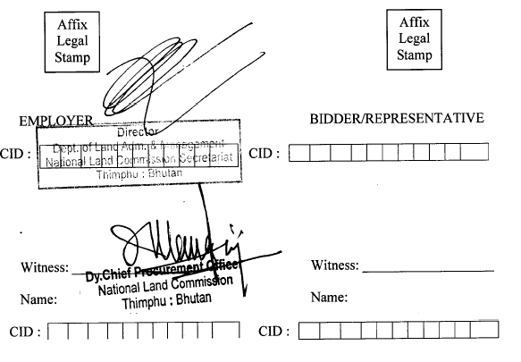

# Section 4. Financial Proposal - Standard Forms

[*Comments in brackets* [ ] *provide guidance to the Consultants for the preparation of their Financial Proposals; they should not appear on the Financial Proposals to be submitted.*]

Financial Proposal Standard Forms shall be used for the preparation of the Financial Proposal according to the instructions provided under paragraph 14 of Section 2. Such Forms are to be used whichever is the selection method indicated in the fourth paragraph of the Letter of Invitation.

[*The Appendix “Financial Negotiations - Breakdown of Remuneration Rates” is only to be used for financial negotiations when Quality-Based Selection, Selection Based on Qualifications, or the Single-Source Selection method is adopted, according to the indications provided under paragraph 24 of Section 2.*]

FIN-1 Financial Proposal Submission Form

FIN-2 Summary of Costs

FIN-3 Breakdown of Costs by Activity

FIN-4 Breakdown of Remuneration

FIN-5 Breakdown of Reimbursable Expenses

Appendix: Financial Negotiations - Breakdown of Remuneration Rates

#### FORM FIN-1 FINANCIAL Proposal Submission Form

............................................................................................................ [*Location, Date*]

To:

…………………………………….

Dear Sirs:

We, the undersigned, offer to provide the Consulting Services for [*Insert title of assignment*] in accordance with your Request for Proposal dated [*Insert Date*] and our Technical Proposal. Our attached Financial Proposal is for the sum of [*Insert amount(s) in words and figures*[12]11]. This amount is exclusive of local taxes, which shall be identified during negotiations and added to the above amount.

Our Financial Proposal shall be binding upon us subject to the modifications resulting from Contract negotiations, up to expiration of the validity period of the Proposal, i.e. before the date indicated in paragraph Reference 7.1 of the Data Sheet.

Commissions and gratuities paid or to be paid by us to agents relating to this Proposal and Contract execution, if we are awarded the Contract, are listed below[13]12:

Name and Address Amount and Purpose of Commission

of Agent Currency or Gratuity

We understand you are not bound to accept any Proposal you receive.

We remain,

Yours sincerely,

Authorized Signature [*In full and initials*]:

Name and Title of Signatory:

Name of Firm:

Address:

**FORM FIN-2 SUMMARY of Costs**

|  |  |  |  |  |
| --- | --- | --- | --- | --- |
| **Item** | **Costs** | | | |
| [Indicate Foreign Currency # 1][14]13 | [Indicate Foreign Currency # 2][15]14 | [Indicate Foreign Currency # 3][16]15 | *Ngultrum* |
| Total Costs of Financial Proposal[17]16 |  |  |  |  |

#### FORM FIN-3 BREAKDOWN of Costs by Activity1

|  |  |  |  |  |
| --- | --- | --- | --- | --- |
| **Group of Activities (Phase)[18]17** | **Description**[19]18 | | | |
| Cost Component | **Costs** | | | |
| [*Indicate Foreign Currency # 1*][20]19 | [*Indicate Foreign Currency # 2*][21]20 | [*Indicate Foreign Currency # 3*][22]21 | [*Indicate Local Currency*] |
| Remuneration |  |  |  |  |
| Reimbursable Expenses |  |  |  |  |
| Subtotals |  |  |  |  |

#### 1 FORM FIN-4 BREAKDOWN of Remuneration1

(This Form FIN-4 shall only be used when the Time-Based Form of Contract has been included in the RFP)

|  |  |  |  |  |  |  |  |  |  |  |
| --- | --- | --- | --- | --- | --- | --- | --- | --- | --- | --- |
| **Group of Activities (Phase):** | | | | | | | | | | |
| **Name**2 | **Position[23]24** | **Staff-month Rate[24]25** | **Input[25]26**  (Staff-months) | [*Indicate Foreign Currency*  *# 1*][26]27 | [*Indicate Foreign Currency*  *# 2*][27]28 | | [*Indicate Foreign Currency*  *# 3*][28]29 | | [*Indicate Local Currency*] | |
| **Foreign Staff** |  |  |  |  |  | | |  |  |  |
|  |  | [*Home*] |  |  |  | | |  |  | |
| [*Field*] |  |  |  | | |  |  | |
|  |  |  |  |  |  | | |  |  | |
|  |  |  |  | | |  |  | |
|  |  |  |  | | |  |  | |
| **Local Staff** |  |  |  |  | |  | | |  | |
|  |  | [*Home*] |  |  |  | | |  |  | |
| [*Field*] |  |  |  | | |  |  | |
|  |  |  |  | | |  |  | |
|  |  |  | Total Costs |  |  | | |  |  | |

**2 FORM FIN-4 BREAKDOWN of Remuneration**

(This Form FIN-4 shall only be used when the Lump-Sum Form of Contract has been included in the RFP. Information to be provided in this Form shall only be used to establish payments to the Consultant for possible additional services requested by the Procuring Agency)

|  |  |  |
| --- | --- | --- |
| **Name**[29]32 | **Position[30]33** | **Staff-month Rate[31]34** |
| **Foreign Staff** |  |  |
|  |  | [*Home*] |
| [*Field*] |
|  |  |  |
|  |
|  |
|  |  |  |
|  |
| **Local Staff** |  |  |
|  |  | [*Home*] |
| [*Field*] |
|  |  |  |
|  |
|  |
|  |  |  |
|  |

### **FORM FIN-5 BREAKDOWN of Reimbursable Expenses**1

(This Form FIN-5 shall only be used when the Time-Based Form of Contract has been included in the RFP)

|  |  |  |  |  |  |  |  |  |  |
| --- | --- | --- | --- | --- | --- | --- | --- | --- | --- |
| **Group of Activities (Phase):** | | | | | | | | | |
| **N°** | **Description35** | **Unit** | **Unit Cost36** | **Quantity** | [*Indicate Foreign Currency*  *# 1*]37 | [*Indicate Foreign Currency*  *# 2*]38 | [*Indicate Foreign Currency*  *# 3*]38 | [*Indicate Local Currency*] | |
|  | Per diem allowances | Day |  |  |  |  |  |  |  |
|  | International flights39 | Trip |  |  |  |  |  |  |  |
|  | Miscellaneous travel expenses | Trip |  |  |  |  |  |  |  |
|  | Communication costs between [*Insert place*] and [*Insert place*] |  |  |  |  |  |  |  |  |
|  | Drafting, reproduction of reports |  |  |  |  |  |  |  |  |
|  | Equipment, instruments, materials, supplies, etc. |  |  |  |  |  |  |  |  |
|  | Shipment of personal effects | Trip |  |  |  |  |  |  |  |
|  | Use of computers, software |  |  |  |  |  |  |  |  |
|  | Laboratory tests |  |  |  |  |  |  |  |  |
|  | Subcontracts |  |  |  |  |  |  |  |  |
|  | Local transportation costs |  |  |  |  |  |  |  |  |
|  | Office rent, clerical assistance |  |  |  |  |  |  |  |  |
|  | Training of the Procuring Agency ’s personnel 6 |  |  |  |  |  |  |  |  |
| Total Costs | | | | |  |  |  |  |  |

35Form FIN-5 should be filled in for each of the Forms FIN-3 provided, if needed.

36Delete items that are not applicable or add other items according to paragraph Reference 14.1 of the Data Sheet.

37Indicate unit cost and currency.

38Indicate between brackets the name of the foreign currency. Use the same columns and currencies of Form FIN-2. Indicate the cost of each reimbursable item in the column of the relevant currency. Cost = Unit Cost x Quantity.

38Indicate route of each flight, and if the trip is one- or two-way.

39Only if the training is a major component of the assignment, defined as such in the TOR.

### **FORM FIN-5 BREAKDOWN of Reimbursable Expenses**

(This Form FIN-5 shall only be used when the Lump-Sum Form of Contract has been included in the RFP. Information to be provided in this Form shall only be used to establish payments to the Consultant for possible additional services requested by the Procuring Agency)

|  |  |  |  |
| --- | --- | --- | --- |
| **N°** | **Description1** | **Unit** | **Unit Cost2** |
|  | Per diem allowances | Day |  |
|  | International flights3 | Trip |  |
|  | Miscellaneous travel expenses | Trip |  |
|  | Communication costs between [*Insert place*] and [*Insert place*] |  |  |
|  | Drafting, reproduction of reports |  |  |
|  | Equipment, instruments, materials, supplies, etc. |  |  |
|  | Shipment of personal effects | Trip |  |
|  | Use of computers, software |  |  |
|  | Laboratory tests |  |  |
|  | Subcontracts |  |  |
|  | Local transportation costs |  |  |
|  | Office rent, clerical assistance |  |  |
|  | Training of the Procuring Agency ’s personnel 4 |  |  |

1 Delete items that are not applicable or add other items according to paragraph Reference 14.1 of the Data Sheet.

2 Indicate unit cost and currency.

3 Indicate route of each flight, and if the trip is one- or two-way.

4 Only if the training is a major component of the assignment, defined as such in the TOR.

# Section 5: Terms of Reference (TOR)

[*Text in brackets provides guidance to the Procuring Agency for the preparation of the RFP; it should not appear on the final RFP to be delivered to the Consultants*]

[*Terms of Reference normally contain the following sections: (a) Background, (b) Objectives, (c) Scope of the Services, (d) Training (when appropriate), (e) Reports and Time Schedule, and (f) Data, Local Services, Personnel and Facilities to be provided by the Procuring Agency .*

*TOR should define clearly the objectives, goals and scope of the assignment, and provide background information (including a list of existing relevant studies and basic data) to facilitate the Consultants’ preparation of their proposals.*

*If transfer of knowledge or training is an objective, it should be specifically outlined along with details of the number of staff to be trained, to enable Consultants to estimate the required resources. TOR should list the services and surveys necessary to carry out the assignment and the expected outputs (for example, reports, data, maps, surveys).*

*However, TOR should not be too detailed and inflexible, so that competing Consultants may propose their own methodology and staffing. Firms should be encouraged to comment on the TOR in their proposals.*

*The Procuring Agency’s and the Consultants’ respective responsibilities should be clearly defined in the TOR.]*

***1) Background***

The rural e-Sakor system was launched in 2011 as land transaction system for land falling in rural areas of Bhutan. It was developed by Swedish consultants with financial assistance from DANIDA.

The system is operational in 15 out of 20 districts where the new certificates were issued after the completion of the nationwide resurveying exercise. In the existing system, land transactions are processed online from the district to the National Land Commission (NLC) online.

At the sub-district level, the citizens still need to fill up a number of forms manually. These forms are then manually forwarded to the district headquarters.

Once the transactions are approved at the NLC, the new certificates are printed and send by post to the districts to be distributed to the citizens.

After its launch in 2011, no upgrade or maintenance of the system has taken place owing to the lack of internal capacity. Over the years, users encountered a number of deficiencies, which couldn't be resolved due to lack of capacity.

The system is also in need of upgrade to incorporate critical components for an effective and transparent land administration system.

Resolving deficiencies in the system and upgrading it by building additional modules will have major impacts in enhancing the quality of land administration system.

The implementation of e-Sakor portal for Urban Land Transactions has enhanced efficiency in delivering land services to the citizens. Therefore, similar e-Sakor portal is being planned for rural land transactions.

***2) Objectives***

The improved system will broadly include the following components:

* Develop e-Sakor portal for Rural Land Transactions
* Integration of the cadastral geodatabase with rural e-Sakor portal.
* Migration of cadastral geodatabase from 9.3 to 10.4 version
* Local development environments that ensure e-Sakor’s flexibility and adaptability.
* Integration of e-Sakor with civil registration database
* Application development for 25 acres land ceiling tracking
* Application for accessing historical data and scanned documents
* Incorporation of Land Mortgage System in e-Sakor

**3) Existing systems and processes**

The land system currently consists of three functions. The following software provides the backend support for the operations.

* The Rural Land Registry: rural e-Sakor.
* The e-Sakor portal for urban.
* The Cadastral Geodatabase

Printing and issuing of ownership certificates, called Lagthrams is the output of the system. Processing land transactions online is a primary function of e-Sakor/ e-Sakor.

In rural e-Sakor, printing is done through VB software, which gets input from Rural e-Sakor software.

The system is entirely managed and hosted at the Land Commission headquarters, and data entry for most transactions is done at the regional (district) offices. Currently, Rural e-Sakor, e-Sakor, and ArcGIS (the land cadastral and urban cadastral software) are functioning separately with a lot of bugs and requirement of manual intervention. The systems are not integrated with each other.

There is no interaction with other external systems like Citizen ID. Currently Citizen ID data is manually imported and used and as a result it is always few months to year old. The initial process through which citizen applies for land transaction is all manual, and all citizens have to bring all record physically to office and go through a manual process.

Currently, the ICT personnel provides needed ICT services at the NLCS. These staff members perform operational activities, including data room management, network management, client-level system troubleshooting, and first-level support for all NLCS systems.

**3.1) Current Processes and Software Systems for rural land transactions**

* NLCS uses 2 systems, which are not integrated with one another.
* Cadastral Geodatabase based on AcrGIS, which is used by both.
* Rural e-Sakor system developed in Microsoft and open source technologies.

- Microsoft VB based system used by Rural e-Sakor to print Lagthrams

### **3.2) Current Software Environment**

|  |  |
| --- | --- |
| **Platform/Engine** | **Rural e-sakor** |
| Operating System | Open Source/ linux/windows |
| User Interface and Business logic Development Platforms | HTML, CSS, JS, AJAX,PHP, MS access |
| Web Services | SOAP Services |
| Database Engine | SQL Server |
| Current Databases | Sathram, e-Sakor Census, e-Sakor User Accounts , e-Sakor Services Directory, e-sakor systems |
| GIS Platform | ArcGIS 9.3 |
| Hosting Environment | Multiple Servers in NLC HQ |

**4) Scope of the Services**

## Features of the proposed system

1. Develop e-Sakor portal for Rural Land Transactions
2. Real time access to cadastral geo DB through rural and urban e-Sakor portal
3. Upgradation of cadastral geodatabase from 9.3 to 10.4 version
4. Integration of e-Sakor with civil registration database
5. Application development for 25 acres land ceiling tracking
6. Application for accessing historical data and scanned documents
7. Migration of Data from MsSQL to MySQL for Rural
8. Common interface for Rural and Urban e-Sakor portal
9. Incorporation of Land Mortgage System in e-Sakor

**4.1. Develop e-Sakor portal for Rural Land Transactions**

* An application with multi channel citizen portal with multichannel access (web and mobile).
* Apply online for a land transfer.
* Bilingual (Dzongkha and English) access of Tharm and census information
* Track the status of an application.
* Receive updates and alerts through SMS / Email.
* Submit queries, complaints, feedback online.
* Printing of LagThrams at the Local Government
* Land Mortgage Module
* Transaction History modules
* Reporting dashboard (Transaction and mortgage overview, escalation matrix, etc)
* System user management

**4.2. Real time access to cadastral geo DB through rural and urban e-Sakor portal**

* Downloading, uploading, editing and conversion into different formats of cadastral DB

**4.3. Upgradation of cadastral geodatabase from 9.3 to 10.4 version**

* Develop Lag Thram printing wizards and Read XML compatible with 10.4 versions for both Urban and Rural.
* Wizards Involves:
* Designing of Lag Thram Templates
* Extracting Thram information from Thram database through Geo DB
* Coordinate extraction from Geo DB for every plot and printing on Lag Thram map

**4.4. Integration of e-Sakor with civil registration database**

* Integration with civil registration system, so that updated citizen record can be accessed in real time.
* Redundant offline backup of census data in NLCS
* Interface to view the census family tree

**4.5. Application development for 25 acres land ceiling tracking**

* Interface development for accessing Thram information from rural and

urban databases for computing land holding under unique household number.

**4.6. Application for accessing historical data and scanned documents.**

Primary Documents for accessing :

* NCRP scanned documents
* NCRP Kappas
* NSC Kappas
* Post NCRP Transaction History

Search criteria using:

* + Thram Number (Old and New), Gewog/Thromde based
  + Plot Number (Old and New), Gewog/Thromde based
  + Transaction ID
  + CID
  + Owner name, Gewog/Thromde based

**4.7. Migration of Data from MsSQL to MySQL for Rural**

* The existing Rural Thram Database is in MsSQL which needs to be migrated to MySQL.

**4.8. Common interface for Rural and Urban e-Sakor portal to be referred to as e-Sakor**

-Common interface for Urban and Rural

-Urban land transaction system uses eCitizen portal while the Rural uses e-Sakor.

-The rural and Urban databases shall be maintained separately in same format while they shall be accessed through a common interfaces

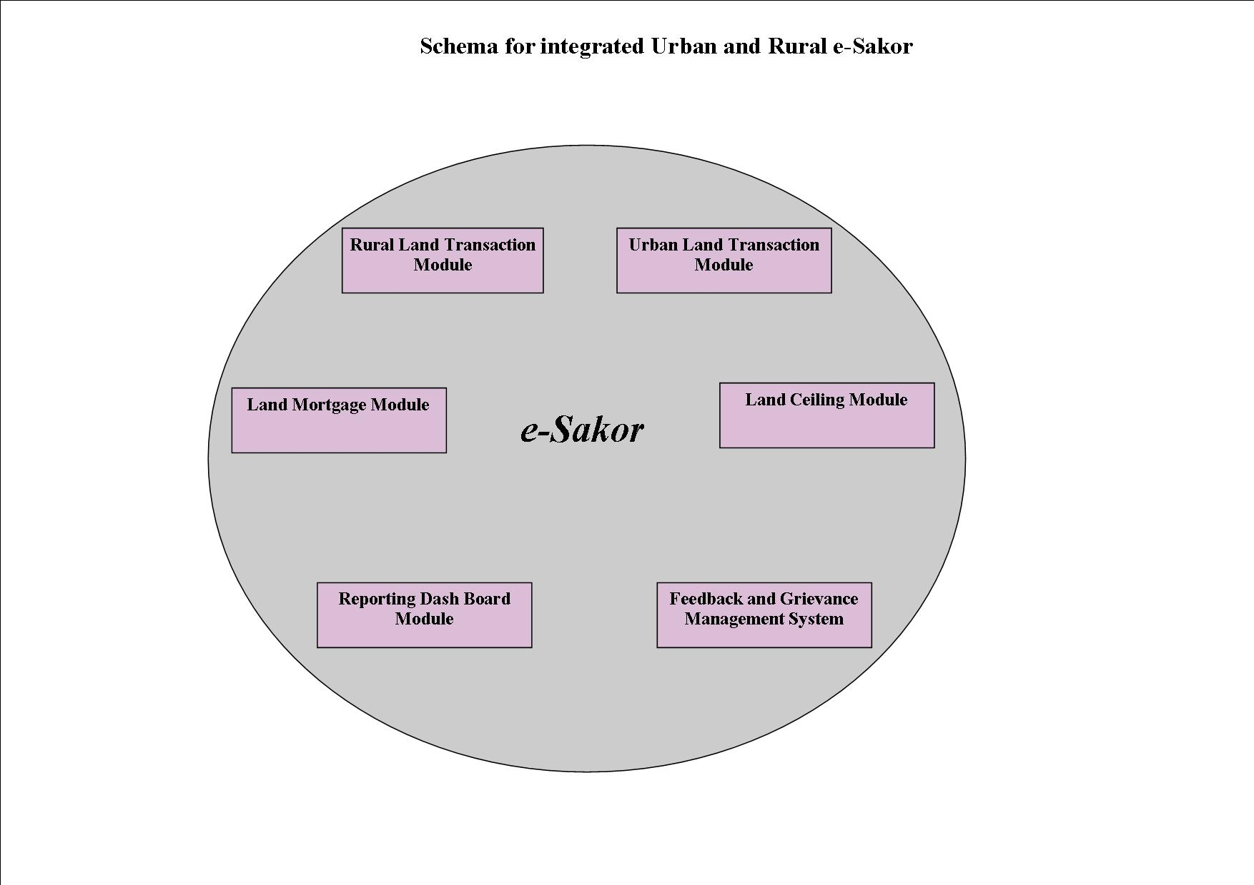

**4.9. Incorporation of Land Mortgage System in e-Sakor**

- Upgrade existing Urban Land Mortage System so that it is able to access Thram information from the Rural Database and use for mortgaging both for Rural and Urban Land.

**5. Description of Land Transaction Process at all levels:**

5.1. At Gewog Level

|  |  |  |  |  |
| --- | --- | --- | --- | --- |
| **Step** | **Function** | **Dealing Officer** | **Current Method** | **Proposed Software Module / Functionality** |
| **1. Submit Application + Doc. via citizen module**  **Documents (Appendix E)** | The **Application Form for Gewog Land Conveyance** (RLT-1) along with the required documents for Land Transfer is submitted online through e-Sakor. | Transferor and Transferee | Manual Submission of Documents at Gewog office. | e-Sakor through Web enabling the Transferor/Transferee to fill the Application Form and upload the required documents.  Once document is registered & accepted a unique ID needs to be generated  The system should be able to fetch personal details from Census and land details from NLCS database.  If the information is not available in the Census database, option should be created for manual entry. |
| **2. Electronic Application Verification** | The Application Form and documents submitted by the Transferor and Transferee are Checked for its completeness by the Dealing Office at Gewog. | LRA | Manual Verification of the forms and documents. | The DO will verify the Application and either Accept or Reject it and inform the Applicant accordingly via. SMS /email. The Status of the transaction will be accordingly noted in the system. |
| **3. Physical Verification of the Document at Gewog** | The Transferor and Transferee come with the original documents for verification at Gewog. The DO Checks the documents for its authenticity. | LG/LRA | Manual | The DO checks the documents for its authenticity and marks the application status as Accepted. |
| **4. Create Public Notice** | A Public Notice is created | LRA | Manually | On initiating the Land Transfer, a Public Notice is created in the standard template. The same is printed for Office Notice Board and automatically publish on the Dzongkhag Website. |
| **5. Field work for plot fragmentation** | If Transaction involves plot fragmentation request for field work is submitted to Dzongkhag/Dungkhag | Surveyor | Surveying is done only after submission of documents after cooling period. | System should notify surveyor to survey.  System should have functionality to schedule/reschedule field work and inform landowner accordingly. |
| **6. Payment to the Revenue Section at Dzongkhag/Drungkhag and Receipt Information Updated** | Payment of Registration fees is done in the Revenue Section at Dzongkhag/Drungkhag | Transferor and Transferee | Manual | Registration Payment is made at the Revenue Section and Receipt Handed over to the DO for Upload.  Suggestion option 1: Integrate Online Payment through BOLTS (Bhutan Online Land Tax System)  Suggestion option 2: Offline Payment and receipt Information updated by Revenue Section. |
| **7. Initiate Transfer** | A Land Transfer is initiated in the system | Dealing Officer | Generated in e-Sakor  Verbally communicated to the Transferor and Transferee | Land Transfer is initiated in the system and submit to the Dzongkhag/Dungkhag after 30 days from the date of submission (observe cooling period) and the status is changed to Registered.  Email / SMS trigger is sent to the Transferor and Transferee about Status. |

5.2. At Dzongkhag / Dungkhag Level

|  |  |  |  |  |
| --- | --- | --- | --- | --- |
| **Step** | **Function** | **Dealing Officer** | **Current Method** | **Proposed Software Module / Functionality** |
| **7. Verification** | The transaction document submitted by the Gewog is verified. | LRA/LRO | Manually | **Accepted:** The application is verified and submitted to NLCS.  If there is no fragmentation, it is submitted to RLD;  The status is changed to Verified  If there is Fragmentation, it is submitted to CID/RLD  The status is changed to Surveyed  **Reject :** The application if rejected is returned back to the Gewog LRA. The remarks specify the items missing and can be resubmitted by the Dealing Officer. |

5.3. At NLCS Level

|  |  |  |  |  |
| --- | --- | --- | --- | --- |
| **Step** | **Function** | **Dealing Officer** | **Current Method** | **Proposed Software Module / Functionality** |
| **8. Verification (Solid plot)** | The transaction document submitted by the Dzongkhag/Drungkhag is verified. | LRA/LR | Manually through e-Sakor | **Accepted:** The application is verified and Approved.  Check list  **Rejected:** The application if Rejected is returned to the Dzongkhag/Drungkhag. |
| **9. Verification (Subdivision- plot)** | The transaction document submitted by the Dzongkhag/Drungkhag is verified by RLD and CID. | LRA/LR and Mapper/ map Verifier | Manually through e-Sakor  -Technical files- See file, CSV, field file, Raw file, field book, survey report | Surveyor at LG should be able to view and download cadastral data in Land XML data.  Submission of technical files through e-Sakor.  **Mapper Verifier:**  **Accepted:** The application is verified and RLD notified.  **RLD Approver:**  Verifies and approves and CID notified for updation  **Rejected:** The application if Rejected is returned to the Surveyor at Dzongkhag/ Drungkhag/ Gewog. |
| **10. Thram/URC generation** | To generate Chhazha Thram/URC for NLCS, Dzongkhag, Drungkhag and Gewog, Lag Thrams/URC and Lag Thram/URC maps. | LRA, LR and Map Verifier | Manual Printing and delivery through Surface transport | Lag Thram/URC Printing wizard to be incorporated  Lag Thram/URC Map Printing to be incorporated  Printing to be enabled at NLCS/LG  SMS alert to be sent to Parties.  Access control and audit trail to be incorporated |

## **5.4. Workflow Diagram for various Transaction Types:**

Depending upon the nature of transactions in terms of work flow and prerequisite documents, the land transactions are broadly divided into two categories as under:

**Category A:**

1. Inheritance
2. Change of ownership type
3. Gift
4. Exchange (Pvt to Pvt)
5. Registration of minor
6. Sale/purchase
7. Yojed
8. Institution Transfer

## **Category B:**

1. Acquisition of Pvt Land

* Substitution
* Cash Compensation
* Substitution & Cash Compensation

1. Acquisition of State Land
2. Correction
3. Disputes/Court Verdict
4. State Land Exchange
5. Kasho

* Freehold
* URC
* Freehold & URC

9. Land Type conversion

* Chuzhing to Khimsa
* Cannot be sold
* Revert to chuzhing if not constructed wihin 3 years

- Chuzhing to Kamzhing

- Other than Chuzhing to other Land type

10. Ommission

11. Substitute

12. Annulment

**Type A:**

* Court verdict
* NLCM/LICM

**Type B:**

* Willful Surrender
* *Tsatong*
* Emigration

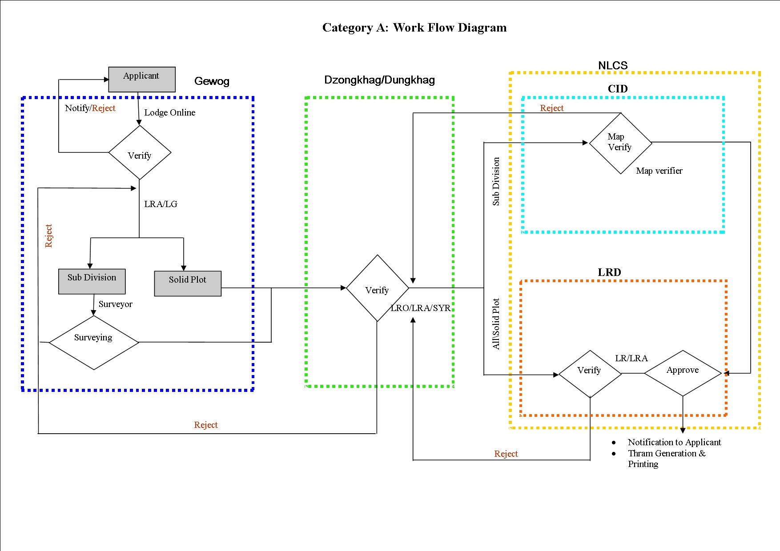

## C:\Users\delol\Desktop\Rural Citizen Portal\Category B1.jpg

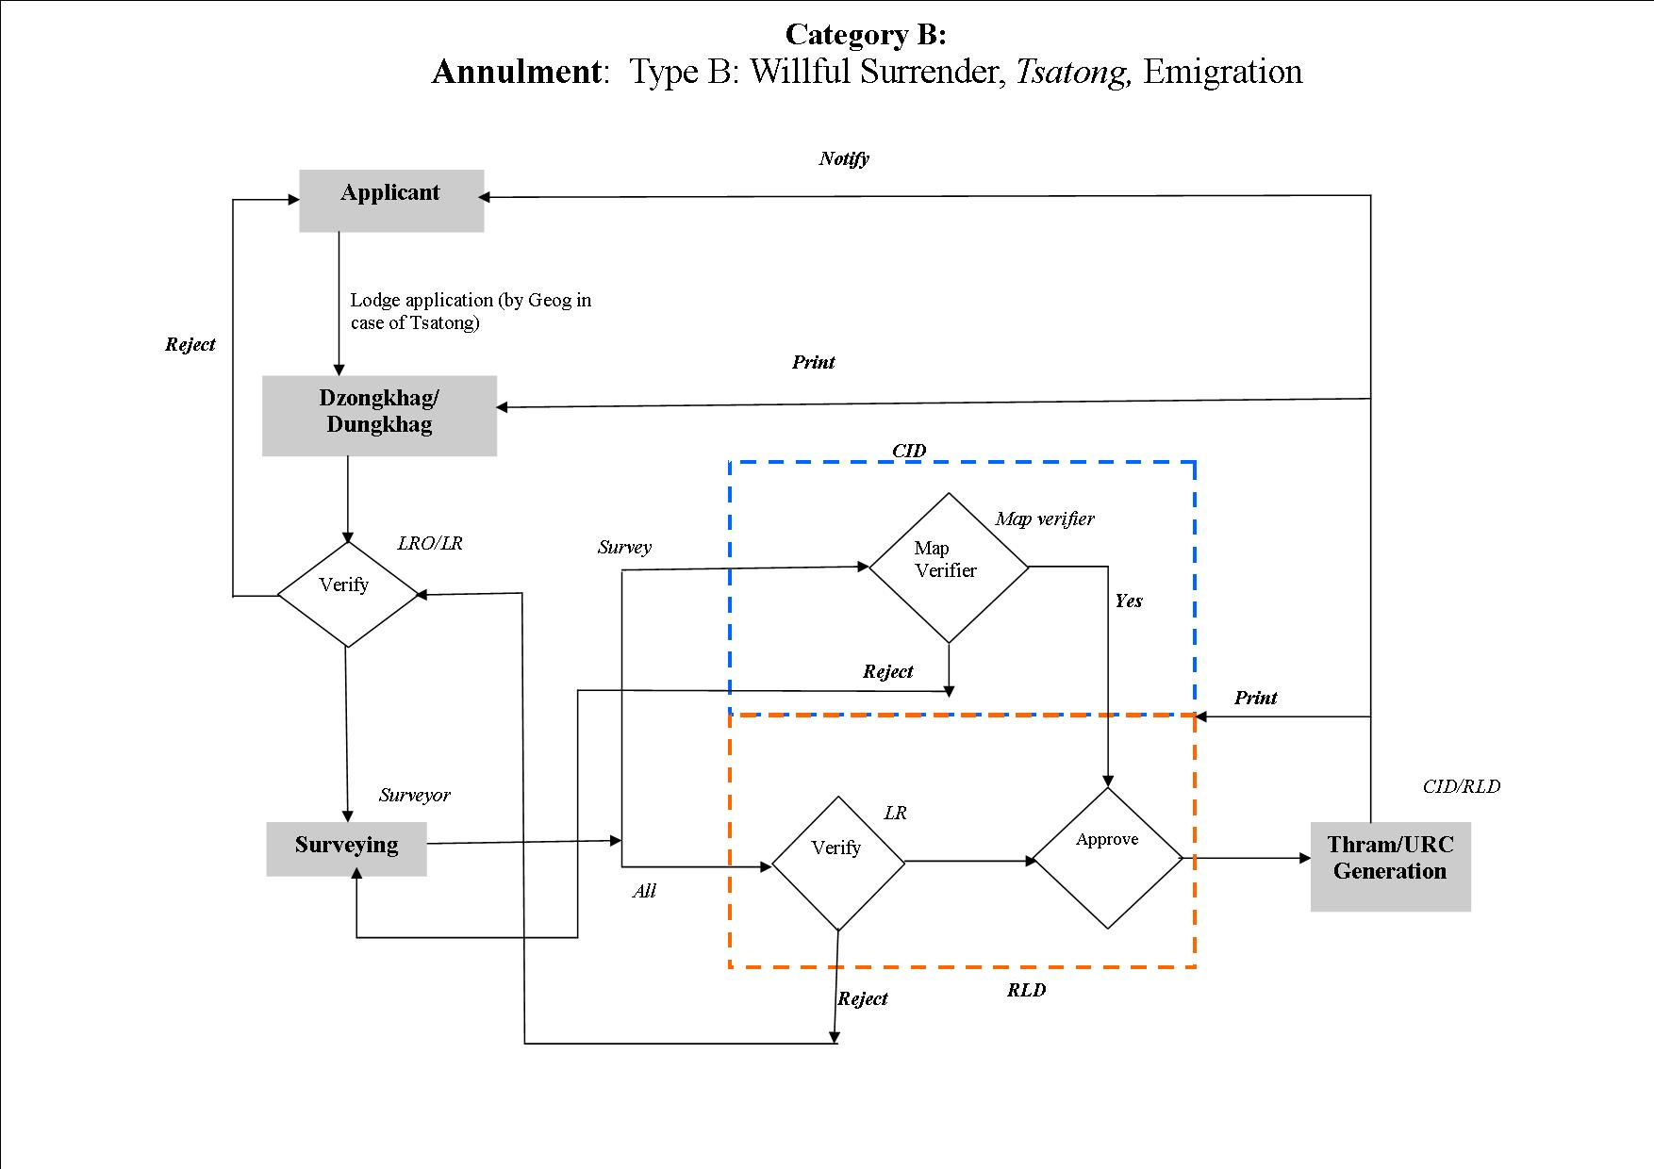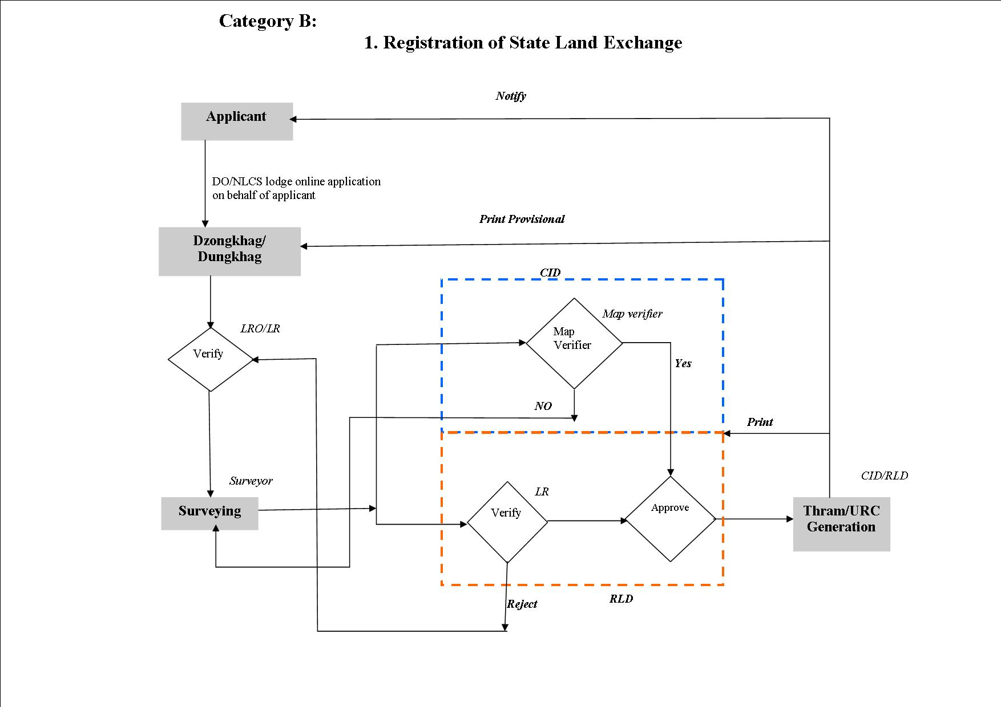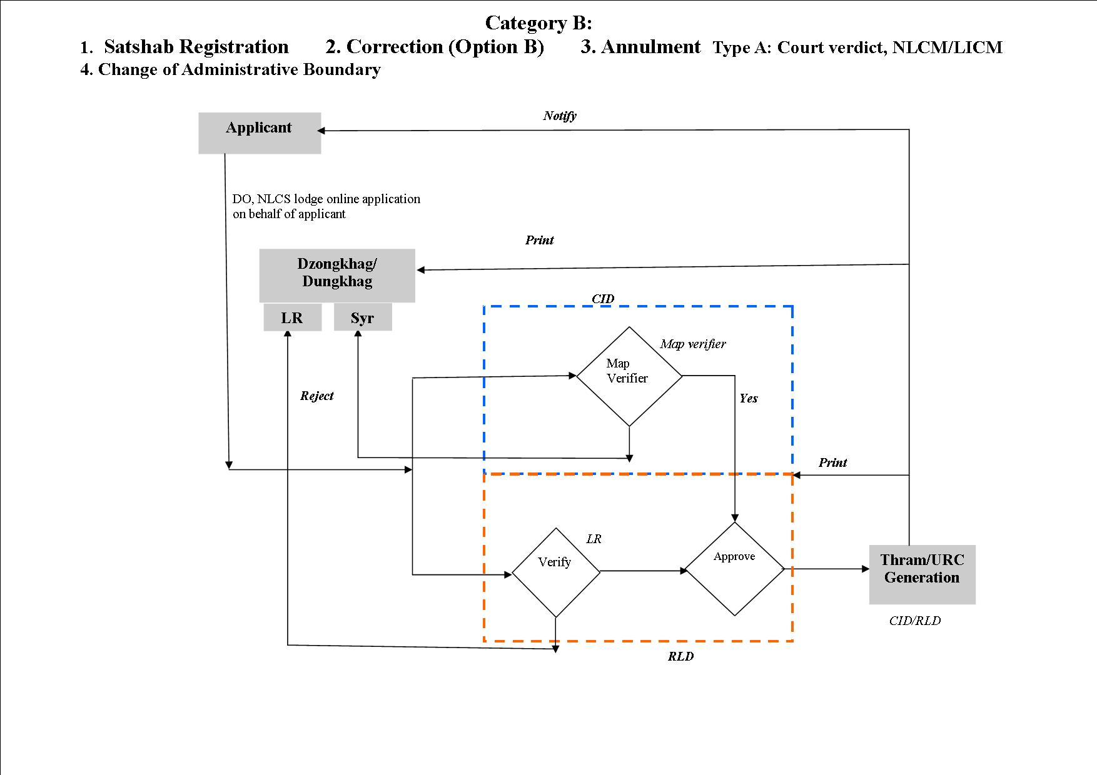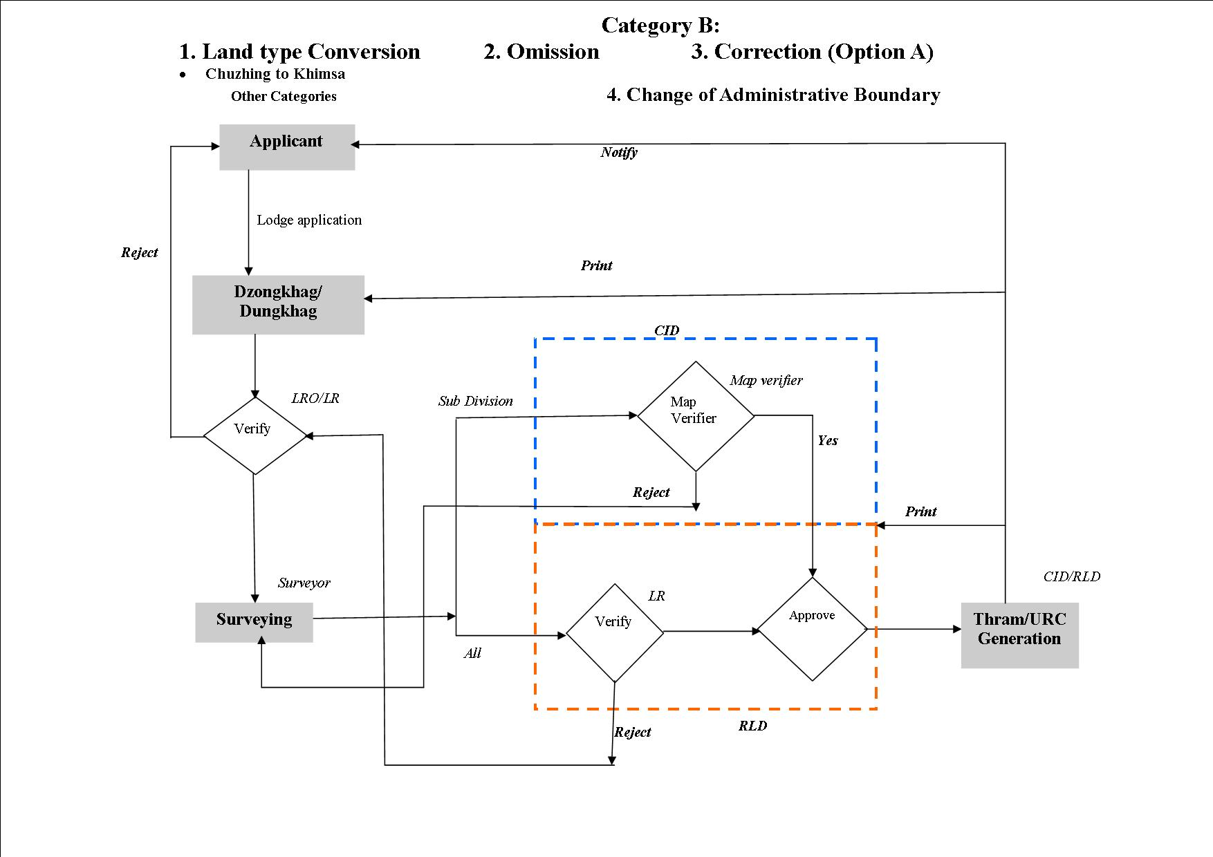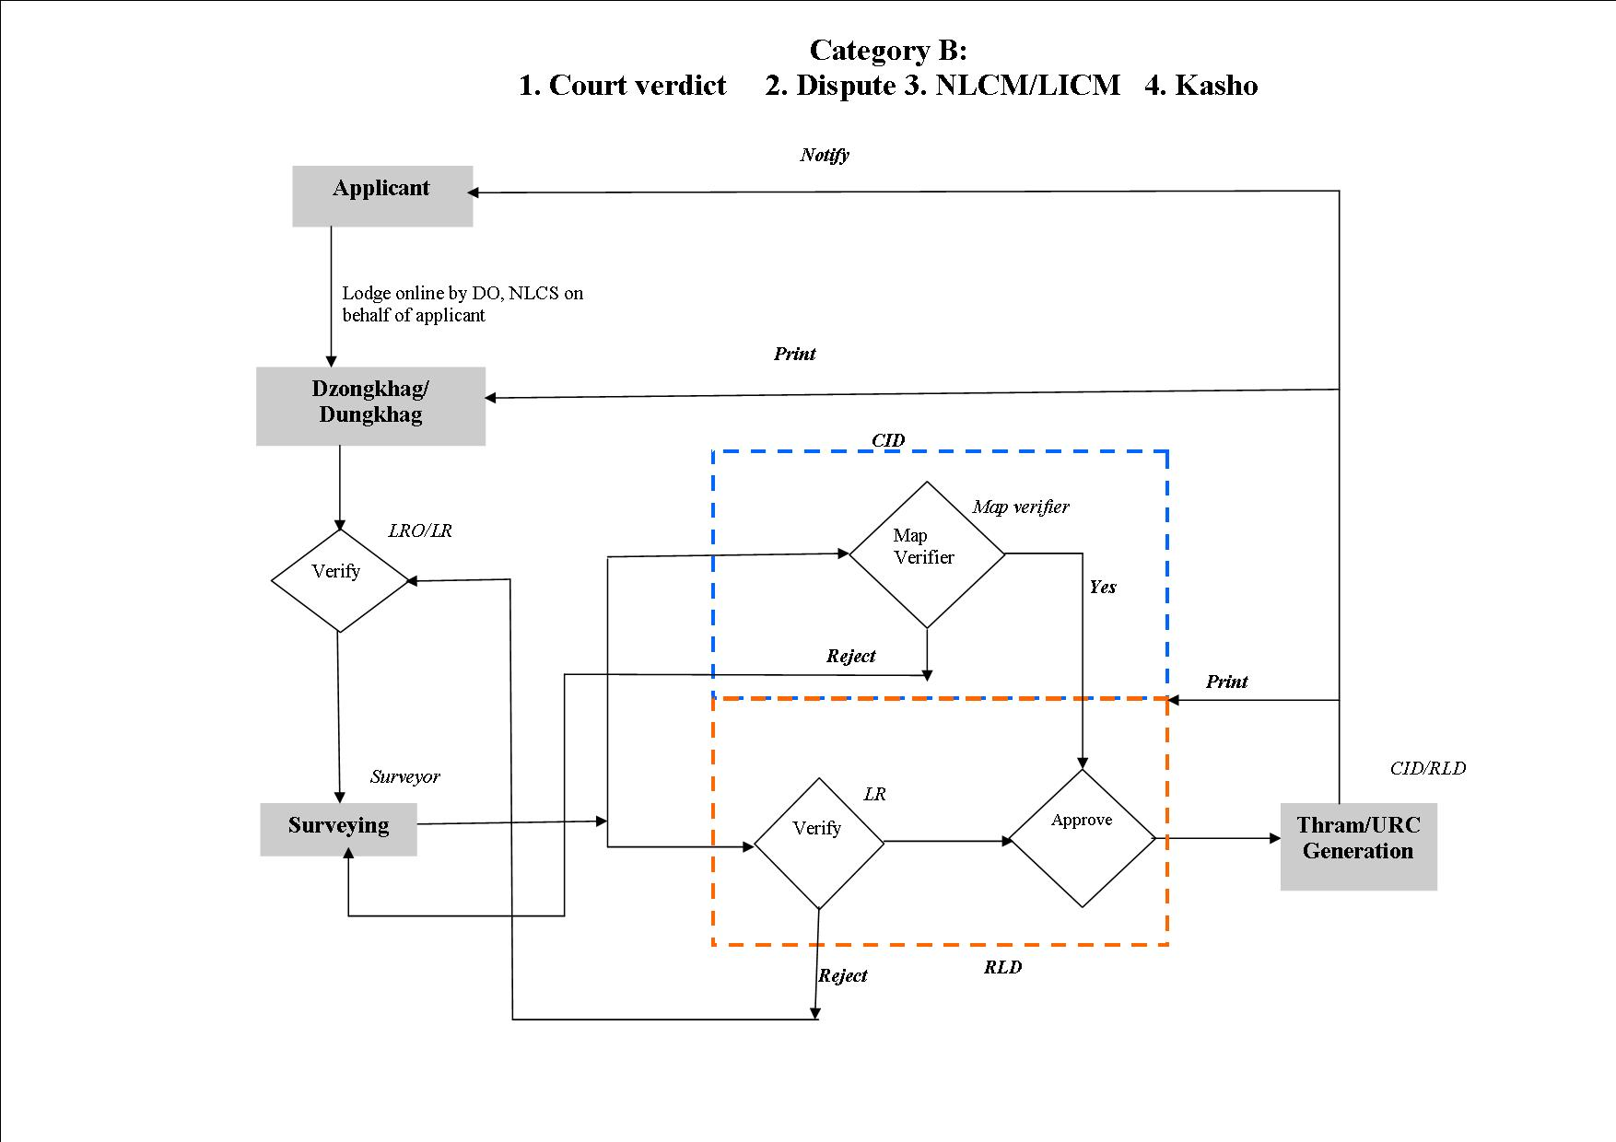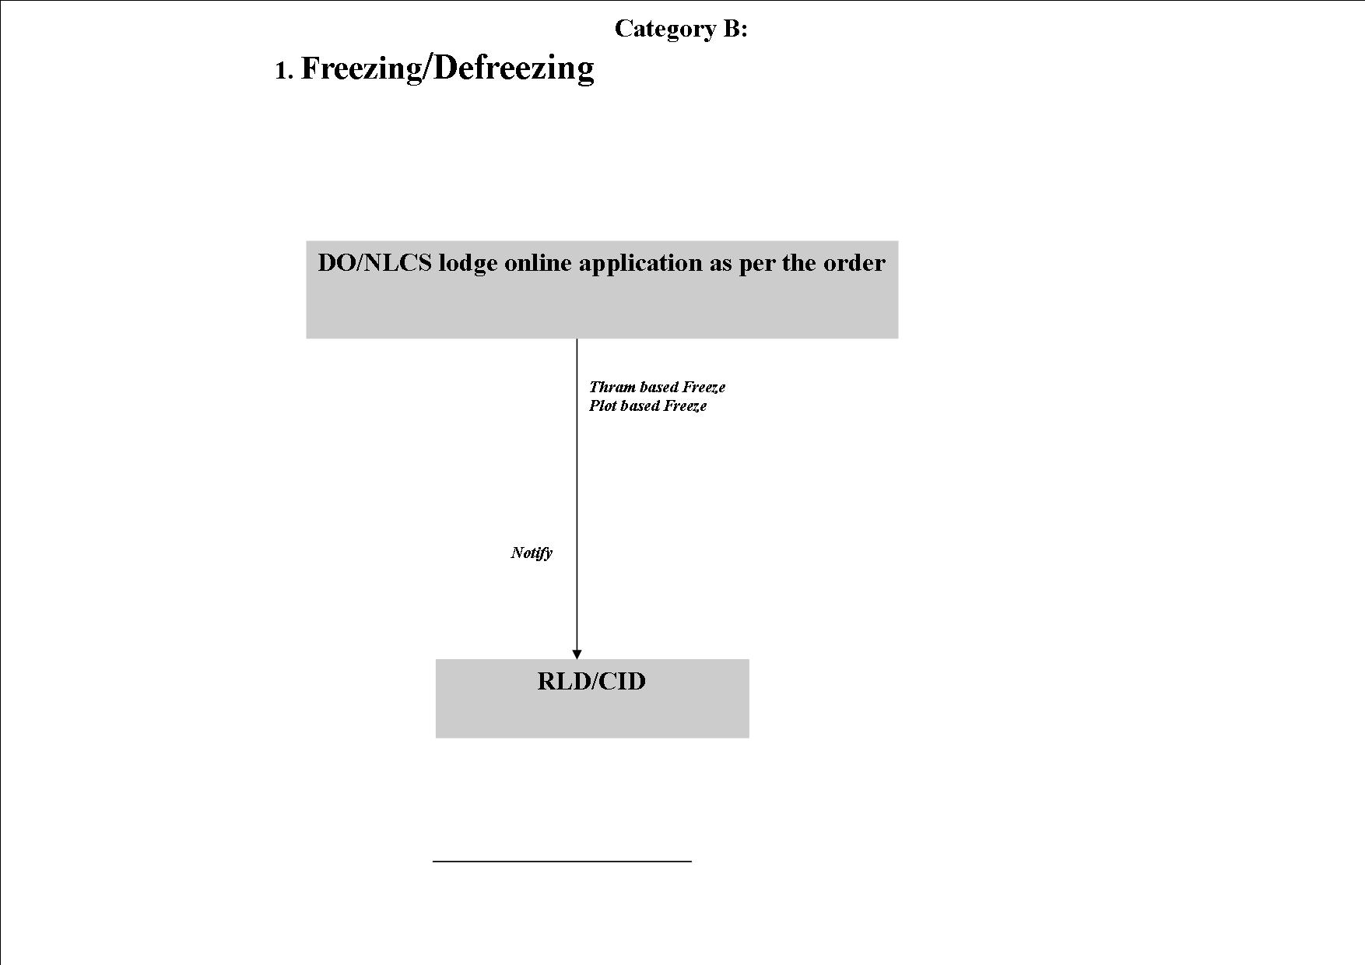

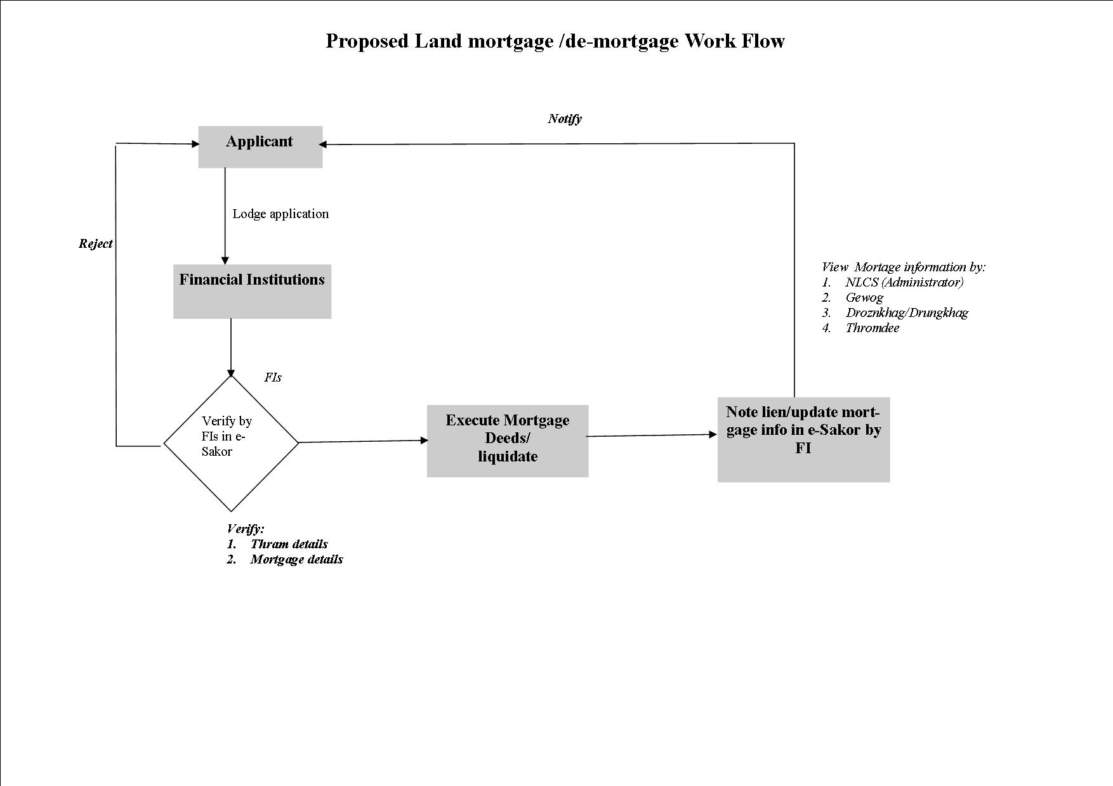

**6. Compliance with standards**

The Application access for Citizen and Government official will be Browser based and Mobile based. The application has to be built up in responsive manner, so that it can support following browsers on Laptop, Desktop as well as Mobiles. The supported browsers should be Firefox, Internet Explorer/Microsoft Edge, Google Chrome, Opera, and Safari. The mobile application should be built up for Android.

## E-Government Interoperability Framework (e GIF):

The software being developed has to follow the e-GIF standard, as defined in the e-Government Interoperability Framework which is available at the link attached: http://www.dit.gov.bt/sites/default/files/page/2013/09/egif_summary_21460.pdf

**7. Deliverables**

7.1. Training and documentation

*User and administrative training needs to be provided to user and IT staff along with project documentation.*

*Source code along with following document needs to be provided to NLC and will remain the property of the NLC and Royal Government of Bhutan.*

7.2. Software architecture

7.3. Software code with documentations

7.4. Design document covering Architecture, Data dictionary, Class Design, Messaging interface, and an Installation manual.

**8. Schedule of Deliverables**

|  |  |  |  |
| --- | --- | --- | --- |
|  | **Activity** | **Timeline** | **Payment**  **schedule** |
| 1 | Contract initiation | Start of contract | 10% |
| 2 | Inception report with work plan | + 30 days | 10% |
| 3 | Complete design of the proposed system | + 99 days | 30% |
| 4 | UAT | + 14 days | 30% |
| 5 | Go live | + 1 day | 10% |
| 6 | End of one year support | 3 Years | 10% |

**9. Data, Local Services, Personnel and Facilities to be provided by the Procuring Agency.**

*The above items necessary for execution of the contracted work shall be provided by the procuring agency subject to availability.*

**10. Details of Downstream Work**

(a) Nature

(b) Scope

(c) Time frame:

# *Section 6: Standard Forms of Contract*

# Consulting Services: Lump-Sum Contract

**STANDARD FORM OF CONTRACT**

**Consulting Services**

Lump-Sum

Preface

1. This standard Contract for Consulting Services has been prepared in line with the RGoB 2009 Procurement Rules and Regulations and is to be used by implementing agencies (referred to hereafter as Procuring Agencies) when they hire a consulting firm (referred to hereinafter as the Consultant) to provide services paid for on a lump-sum basis.

2. The Contract includes four parts:

* Form of Contract
* General Conditions of Contract
* Special Conditions of Contract
* Appendices

1. The Procuring Agency using this standard Contract should not alter the General Conditions. Any adjustment to meet project features should be made only in the Special Conditions.

4. Lump-sum Contracts are normally used when definition of the tasks to be performed is clear and unambiguous, when the commercial risks taken by the Consultant are relatively low, and when therefore such Consultant is prepared to perform the assignment for an agreed predetermined lump-sum price. Such price is arrived at on the basis of inputs - including rates - provided by the Consultant. The Procuring Agency agrees to pay the Consultant according to a schedule of payments linked to the delivery of certain outputs, for example reports. A major advantage of the lump-sum Contract is the simplicity of its administration, the Procuring Agency having only to be satisfied with the outputs without monitoring the staff inputs. Studies are usually carried out on a lump-sum basis; for example, surveys, master plans, economic, sector, simple feasibility and engineering studies.

**Contract for Consulting Services**

**Lump-Sum**

between

[name of the Procuring Agency]

and

[name of the Consultant]

Dated:

I. Form of Contract

**Lump-Sum**

(Text in brackets [ ] is optional; all notes should be deleted in final text)

This CONTRACT (hereinafter called the “Contract”) is made the *[day]* day of the month of *[month]*, *[year]*, between, on the one hand, *[name of Procuring Agency]* (hereinafter called the “Procuring Agency”) and, on the other hand, *[name* of Consultant*]* (hereinafter called the “Consultant”).

[***Note****: If the Consultant consist of more than one entity, the above should be partially amended to read as follows:* “…(hereinafter called the “Procuring Agency”) and, on the other hand, a joint venture/consortium/association consisting of the following entities, each of which will be jointly and severally liable to the Procuring Agency for all the Consultant’s obligations under this Contract, namely, *[name of Consultant]* and *[name of Consultant]* (hereinafter called the “Consultant”).]

WHEREAS

(a) the Procuring Agency has requested the Consultant to provide certain consulting services as defined in this Contract (hereinafter called the “Services”);

(b) the Consultant, having represented to the Procuring Agency that it has the required professional skills, personnel and technical resources, has agreed to provide the Services on the terms and conditions set forth in this Contract;

NOW THEREFORE the parties hereto hereby agree as follows:

1. The following documents attached hereto shall be deemed to form an integral part of this Contract:

II. The General Conditions of Contract;

III. The Special Conditions of Contract;

IV. The following Appendices: [***Note****: If any of these Appendices are not used, the words “Not Used” should be inserted below next to the title of the Appendix*]

Appendix A: Description of Services Not used

Appendix B: Reporting Requirements Not used

Appendix C: Key Personnel and Sub-Consultants Not used

Appendix D: Breakdown of Contract Price in Foreign Currency Not used

Appendix E: Breakdown of Contract Price in Local Currency Not used

Appendix F: Services and Facilities Provided by the Procuring Agency Not used

Appendix G: Form of Advance Payment Guarantee Not used

2. The mutual rights and obligations of the Procuring Agency and the Consultant shall be as set forth in the Contract, in particular:

(a) the Consultant shall carry out the Services in accordance with the provisions of the Contract; and

(b) the Procuring Agency shall make payments to the Consultant in accordance with the provisions of the Contract.

IN WITNESS WHEREOF, the Parties hereto have caused this Contract to be signed in their respective names as of the day and year first above written.

For and on behalf of *[name of Procuring Agency]*

*[Authorized Representative]*

For and on behalf of *[name of Consultant]*

*[Authorized Representative]*

[***Note****: If the Consultant consists of more than one entity, all these entities should appear as signatories, e.g., in the following manner*:]

For and on behalf of each of the Members of the Consultant

*[name of member]*

*[Authorized Representative]*

*[name of member]*

*[Authorized Representative]*

II. General Conditions of Contract

1. General Provisions

|  |  |
| --- | --- |
| * 1. Definitions | Unless the context otherwise requires, the following terms whenever used in this Contract have the following meanings:  **(a) Applicable Laws of Bhutan:** The laws and any other instruments having the force of law in Bhutan  **(b) Consultant:** An individual or a legal entity entering into a Contract to provide the Services to the Procuring Agency under the Contract.  **(c) Consulting Services:** Expert services of a professional and/or intellectual nature, provided by the Consultant based on specialized expertise and skills, in areas including, but not limited to, preparing and implementing projects, conducting training, providing technical assistance, conducting research and analysis, preparing designs, supervising the execution of construction and other works, undertaking studies, advising Procuring Agencies, building capacity, preparing tender documents, supervising procurement, and others.  **(d) Contract:** The formal agreement in writing, including the General Conditions (GC), the Special Conditions (SC), and the Appendices, entered into between the Procuring Agency and the Consultant, on acceptable terms and conditions and which are in compliance with all the relevant provisions of the laws of the Kingdom of Bhutan, for the provision of the required Consulting Services.  **(e) Contract Price:** The price to be paid for the performance of the Services, in accordance with Clause 6;  **(f) Day:** A calendar day.  **(g) Effective Date:** The date on which this Contract comes into force and effect pursuant to Clause GC 2.1.  **(h) Foreign Currency:** Any currency other than Bhutanese Ngultrum (BTN).  **(i) GC:** These General Conditions of Contract.  **(j) Government:** The Royal Government of Bhutan (RGoB).  **(k) In writing:** Communicated in written form (e.g. by mail, electronic mail, fax, telex) with proof of receipt.  **(l)Local Currency:** Bhutanese Ngultrum (BTN).  **(m) Member:** Any of the entities that make up the joint venture/consortium/association; and “Members” means all these entities.  **(n) Party:** The Procuring Agency or the Consultant, as the case may be, and “Parties” means both of them.  **(o) Personnel:** Professional and support staff provided by the Consultant or by any Sub-Consultant and assigned to perform the Services or any part thereof; “Foreign Personnel” means such professional and support staff who at the time of being so provided have their domicile outside Bhutan; “Local Personnel” means such professional and support staff who at the time of being so provided have their domicile in Bhutan; and “Key Personnel” means the Personnel referred to in Clause GC 4.2(a).  **(p) Procuring Agency:** RGoB agency with which the selected Consultant signs the Contract for Services.  **(q) Reimbursable Expenses:** All assignment-related costs other than Consultant’s remuneration.  **(r) SC:** The Special Conditions of Contract by which the GC may be amended or supplemented.  **(s) Services:** The work to be performed by the Consultant pursuant to this Contract, as described in Appendix A hereto.  **(t) Sub-Consultant**: Any person or entity to whom/which the Consultant subcontracts any part of the Services.  **(u) Third Party**: Any person or entity other than the Government, the Procuring Agency, the Consultant or a Sub-Consultant. |
| 1.2 Law Governing Contract | This Contract, its meaning and interpretation, and the relation between the Parties shall be governed by the Applicable Laws of Bhutan. |
| 1.3 Language | This Contract has been executed in the language specified in the SC, which shall be the binding and controlling language for all matters relating to the meaning or interpretation of this Contract. |
| 1.4 Notices |  |
| 1.4.1 | Any notice, request or consent required or permitted to be given or made pursuant to this Contract shall be in writing. Any such notice, request or consent shall be deemed to have been given or made when delivered in person to an authorized representative of the Party to whom the communication is addressed, or when sent to such Party at the address specified in the SC. |
| 1.4.2 | A Party may change its address for notice hereunder by giving the other Party notice in writing of such change to the address specified in the SC. |
| 1.5 Location | The Services shall be performed at such locations as are specified in Appendix A hereto and, where the location of a particular task is not so specified, at such locations, whether in Bhutan or elsewhere, as the Procuring Agency may approve. |
| 1.6 Authority of Member in Charge | In case the Consultant consists of a joint venture/consortium/ association of more than one entity, the Members hereby authorize the entity specified in the SC to act on their behalf in exercising all the Consultant’s rights and obligations towards the Procuring Agency under this Contract, including without limitation the receiving of instructions and payments from the Procuring Agency. |
| 1.7 Authorized Representa­tives | Any action required or permitted to be taken, and any document required or permitted to be executed under this Contract by the Procuring Agency or the Consultant may be taken or executed by the officials specified in the SC. |
| 1.8 Taxes and Duties | The Consultant, Sub-Consultants, and the Personnel of both of them shall pay such indirect taxes, duties, fees and other impositions levied under the Applicable Laws of Bhutan as are specified in the SC, the amount of which is deemed to have been included in the Contract Price. |
| 1.9 Fraud and Corruption |  |
| 1.9.1 Definitions | It is RGoB policy to require that Consultants, their Sub-Consultants and the Personnel of both of them observe the highest standards of ethics during the execution of the Contract.[32]50 In pursuance of this policy, the RGoB:  (a) defines, for the purposes of this provision, the terms set forth below as follows:  (i) “corrupt practice”[33]51 means the offering, giving, receiving or soliciting, directly or indirectly, of anything of value[34]52 to influence improperly the actions of another party;  (ii) “fraudulent practice”[35]53 means any intentional act or omission, including a misrepresentation, that knowingly or recklessly misleads, or attempts to mislead, a party to obtain a financial or other benefit or to avoid an obligation;  (iii) “collusive practice”[36]54 means an arrangement between two or more parties designed to achieve an improper purpose, including to influence improperly the actions of another party;  (iv) “coercive practice”[37]55 means impairing or harming, or threatening to impair or harm, directly or indirectly, any party or the property of the party to influence improperly the actions of a party;  (v) "obstructive practice" means:  (aa) deliberately destroying, falsifying, altering or concealing of evidence material to the investigation or making false statements to investigators in order materially to impede any investigation into allegations of a corrupt, fraudulent, coercive or collusive practice; and/or threatening, harassing or intimidating any party to prevent it from disclosing its knowledge of matters relevant to the investigation or from pursuing the investigation; or  (bb) acts intended materially to impede the exercise of the inspection and audit rights of the Procuring Agency or any organization or person appointed by the Procuring Agency and/or any relevant RGoB agency provided for under Clause GC 3.8 (b). |
| 1.9.2 Measures to be Taken | (b) will cancel the Contract if it at any time determines that representatives of the Consultant, any Sub-Consultant, the personnel of either of them, or any other participant in the procurement and Contract execution process, were engaged in corrupt, fraudulent, collusive, coercive or obstructive practices during the procurement and selection process or the execution of the Contract;  (c) will sanction a Consultant, Sub-Consultant or the personnel of either of them, including declaring them ineligible, either indefinitely or for a stated period of time, to be awarded an RGoB-financed contract if at any time it determines that they have, directly or through an agent, engaged in corrupt, fraudulent, collusive, coercive or obstructive practices in competing for, or in executing, an RGoB-financed contract;  (d) will report the case of corrupt, fraudulent, collusive, coercive or obstructive practice to the relevant RGoB agencies, including but not limited to the Anticorruption Commission (ACC) of Bhutan, for necessary action in accordance with the statutes and provisions of the relevant agency. |
| 1.9.3Commissions and Fees | (e) will require the successfulConsultant to disclose any commissions or fees that may have been paid or are to be paid to agents, representatives or commission agents with respect to the selection process or execution of the Contract. The information disclosed must include at least the name and address of the agent, representative or commission agent, the amount and currency, and the purpose of the commission or fee. |

2. Commencement, Completion, Modification and Termination of Contract

|  |  |
| --- | --- |
| 2.1 Effectiveness of Contract | This Contract shall come into force and effect on the date (the “Effective Date”) of the Procuring Agency’s notice to the Consultant instructing the Consultant to begin carrying out the Services. This notice shall confirm that the effectiveness conditions, if any, listed in the SC have been met. |
| 2.2 Commence­ment of Services | The Consultant shall begin carrying out the Services not later than the number of days after the Effective Date specified in the SC. |
| 2.3 Expiration of Contract | Unless terminated earlier pursuant to Clause GC 2.6 hereof, this Contract shall expire at the end of such time period after the Effective Date as is specified in the SC. |
| 2.4 Modifications or Variations | Any modification or variation of the terms and conditions of this Contract, including any modification or variation of the scope of the Services, may only be made by written agreement between the Parties. However, each Party shall give due consideration to any proposals for modification or variation made by the other Party. |
| 2.5 Force Majeure |  |
| 2.5.1 Definition | For the purposes of this Contract, “Force Majeure” means an event which is beyond the reasonable control of a Party and which makes a Party’s performance of its obligations under the Contract impossible or so impractical as to be considered impossible under the circumstances. |
| 2.5.2 No Breach of Contract | The failure of a Party to fulfill any of its obligations under the Contract shall not be considered to be a breach of, or default under, this Contract insofar as such inability arises from an event of Force Majeure, provided that the Party affected by such an event (a) has taken all reasonable precautions, due care and reasonable alternative measures in order to carry out the terms and conditions of this Contract, and (b) has informed the other Party as soon as possible about the occurrence of such an event. |
| 2.5.3 Extension of Time | Any period within which a Party shall, pursuant to this Contract, complete any action or task, shall be extended for a period equal to the time during which such Party was unable to perform such action as a result of Force Majeure. |
| 2.5.4 Payments | During the period of its inability to perform the Services as a result of an event of Force Majeure, the Consultant shall be entitled to continue to be paid under the terms of this Contract, as well as to be reimbursed for additional costs reasonably and necessarily incurred by it during such period for the purposes of the Services and in reactivating the Service after the end of such period. |
| 2.6 Termination |  |
| 2.6.1 By the Procuring Agency | The Procuring Agency may terminate this Contract in case of the occurrence of any of the events specified in paragraphs (a) through (f) of this Clause GC 2.6.1. In such an occurrence the Procuring Agency shall give not less than thirty (30) days written notice of termination to the Consultant, or sixty (60) days in the case of the event referred to in paragraph (e) of this Clause GC 2.6.1.  (a) If the Consultant does not remedy a failure in the performance of its obligations under the Contract within thirty (30) days after being notified or within any further period as the Procuring Agency may have subsequently approved in writing.  (b) If the Consultant becomes insolvent or bankrupt.  (c) If the Consultant, in the judgment of the Procuring Agency has engaged in corrupt or fraudulent practices in competing for or in executing the Contract.  (d) If, as the result of Force Majeure, the Consultant is unable to perform a material portion of the Services for a period of not less than sixty (60) days.  (e) If the Procuring Agency, in its sole discretion and for any reason whatsoever, decides to terminate this Contract.  (f) If the Consultant fails to comply with any final decision reached as a result of arbitration proceedings pursuant to Clause GC 8 hereof. |
| 2.6.2 By the Consultant | The Consultant may terminate this Contract, by not less than thirty (30) days written notice to the Procuring Agency, such notice to be given after the occurrence of any of the events specified in paragraphs (a) through (c) of this Clause GC 2.6.2:  (a) If the Procuring Agency fails to pay any money due to the Consultant pursuant to this Contract and not subject to dispute pursuant to Clause GC 8 hereof within forty-five (45) days after receiving written notice from the Consultant that such payment is overdue.  (b) If, as the result of Force Majeure, the Consultant is unable to perform a material portion of the Services for a period of not less than sixty (60) days.  (c) If the Procuring Agency fails to comply with any final decision reached as a result of arbitration pursuant to Clause GC 8 hereof. |
| 2.6.3 Payment upon Termina­tion | Upon termination of this Contract pursuant to Clauses GC 2.6.1 or GC 2.6.2, the Procuring Agency shall make the following payments to the Consultant:  (a) payment pursuant to Clause GC 6 for Services satisfactorily performed prior to the effective date of termination;  (b) except in the case of termination pursuant to paragraphs (a) through (c) and (f) of Clause GC 2.6.1, reimbursement of any reasonable cost incident to the prompt and orderly termination of the Contract, including the cost of the return travel of the Personnel and their eligible dependents. |

3. Obligations of the Consultant

|  |  |  |
| --- | --- | --- |
| 3.1 General |  | |
| 3.1.1Standard of Perform­ance | The Consultant shall perform the Services and carry out its obligations hereunder with all due diligence, efficiency and economy, in accordance with generally accepted professional standards and practices, and shall observe sound management practices, and employ appropriate technology and safe and effective equipment, machinery, materials and methods. The Consultant shall always act, in respect of any matter relating to this Contract or to the Services, as faithful adviser to the Procuring Agency, and shall at all times support and safeguard the Procuring Agency’s legitimate interests in any dealings with Sub-Consultants or third Parties. | |
| 3.2 Conflict of Interests | The Consultant shall hold the Procuring Agency’s interests paramount, without any consideration for future work, and strictly avoid conflict with other assignments or its own corporate interests. | |
| 3.2.1 Consult­ant Not to Benefit from Commis­sions, Dis­counts, etc. | The payment of the Consultant pursuant to Clause GC 6 shall constitute the Consultant’s only payment in connection with this Contract or the Services, and the Consultant shall not accept for its own benefit any trade commission, discount or similar payment in connection with activities pursuant to this Contract or to the Services or in the discharge of its obligations under the Contract, and the Consultant shall use its best efforts to ensure that the Personnel, any Sub-Consultants, and agents of either of them similarly shall not receive any such additional payment. | |
| 3.2.2 Consultant and Affiliates Not to be Otherwise Interested in Project | The Consultant agrees that, during the term of this Contract and after its termination, the Consultant and any entity affiliated with the Consultant, as well as any Sub-Consultants and any entity affiliated with such Sub-Consultants, shall be disqualified from providing goods, works or services (other than consulting services) resulting from or directly related to the Consultant’s Services for the preparation or implementation of the project. | |
| 3.2.3 Prohibition of Conflicting Activities | The Consultant shall not engage, and shall cause its Personnel as well as its Sub-Consultants and their Personnel not to engage, either directly or indirectly, in any business or professional activities which would conflict with the activities assigned to them under this Contract. | |
| 3.3 Confidentiality | Except with the prior written consent of the Procuring Agency, the Consultant and the Personnel shall not at any time communicate to any person or entity any confidential information acquired in the course of the Services, nor shall the Consultant and the Personnel make public the recommendations formulated in the course of, or as a result of, the Services. | |
| 3.4 Insurance to be Taken Out by the Consultant | The Consultant (a) shall take out and maintain, and shall cause any Sub-Consultants to take out and maintain, at their (or the Sub-Consultants’, as the case may be) own cost but on terms and conditions approved by the Procuring Agency, insurance against the risks, and for the coverage, as shall be specified in the SC; and (b) at the Procuring Agency’s request, shall provide evidence to the Procuring Agency showing that such insurance has been taken out and maintained and that the current premiums have been paid. | |
| 3.5 Consultant’s Actions Requiring Procuring Agency’s Prior Approval | The Consultant shall obtain the Procuring Agency’s prior approval in writing before taking any of the following actions:  (a) entering into a subcontract for the performance of any part of the Services,  (b) appointing such members of the Personnel not listed by name in Appendix C, and  (c) any other action that may be specified in the SC. |  |
| 3.6 Reporting Obligations | (a) The Consultant shall submit to the Procuring Agency the reports and documents specified in Appendix B hereto, in the form, in the numbers and within the time periods set forth in the said Appendix.  (b) Final reports shall be delivered on CD ROM in addition to the hard copies specified in the said Appendix. |  |
| 3.7 Documents Prepared by the Consultant to be the Property of the Procuring Agency | (a) All plans, drawings, specifications, designs, reports, other documents and software submitted by the Consultant under this Contract shall become and remain the property of the Procuring Agency, and the Consultant shall, not later than upon termination or expiration of this Contract, deliver all such documents to the Procuring Agency, together with a detailed inventory thereof.  (b) The Consultant may retain a copy of such documents and software. Restrictions about the future use of these documents, if any, shall be specified in the SC. |  |
| 3.8 Accounting, Inspection and Auditing | The Consultant:  (a) shall keep accurate and systematic accounts and records in respect of the Services hereunder, in accordance with internationally accepted accounting principles and in such form and detail as will clearly identify all relevant time charges and costs, and the bases thereof, and  (b) shall periodically permit the Procuring Agency or its designated representative, for a period of up to five years from the expiration or termination of this Contract, to inspect the same and make copies thereof as well as to have them audited by auditors, if so required by the Procuring Agency. |  |

4. CONSULTANT’S Personnel

|  |  |
| --- | --- |
| 4.1 Description of Personnel | The Consultant shall employ and provide such qualified and experienced Personnel and Sub-Consultants as are required to carry out the Services. The titles, agreed job descriptions, minimum qualifications and estimated periods of engagement in the carrying out of the Services of the Consultant’s Key Personnel are described in Appendix C. The Key Personnel and Sub-Consultants listed by title as well as by name in Appendix C are hereby approved by the Procuring Agency. |
| 4.2 Removal and/or Replacement of Personnel | (a) Except as the Procuring Agency may otherwise agree, no changes shall be made in the Key Personnel. If, for any reason beyond the reasonable control of the Consultant, such as retirement, death, medical incapacity, among others, it becomes necessary to replace any of the Key Personnel, the Consultant shall provide as a replacement a person of equivalent or better qualifications.  (b) If the Procuring Agency (i) finds that any of the Personnel have committed serious misconduct or have been charged with having committed a criminal action, or (ii) has reasonable cause to be dissatisfied with the performance of any of the Personnel, then the Consultant shall, at the Procuring Agency’s written request specifying the grounds thereof, provide as a replacement a person with qualifications and experience acceptable to the Procuring Agency.  (c) The Consultant shall have no claim for additional costs arising out of or incidental to any removal and/or replacement of Personnel. |
| 4.3 Resident Project Manager | If required by the SC, the Consultant shall ensure that at all times during the Consultant’s performance of the Services in Bhutan a resident project manager, acceptable to the Procuring Agency, shall take charge of the performance of the Services. |

5. Obligations of the Procuring Agency

|  |  |
| --- | --- |
| 5.1 Assistance and Exemptions | The Procuring Agency shall use its best efforts to ensure that the Government shall provide the Consultant such assistance and exemptions as are specified in the SC. |
| 5.2 Change in the Applicable Laws of Bhutan Related to Taxes and Duties | If, after the date of this Contract, there is any change in the Applicable Laws of Bhutan with respect to taxes and duties which increases or decreases the cost incurred by the Consultant in performing the Services, then the remuneration and reimbursable expenses otherwise payable to the Consultant under this Contract shall be increased or decreased accordingly by agreement between the Parties, and corresponding adjustments shall be made to the amounts referred to in Clauses GC 6.2 (a) or (b), as the case may be. |
| 5.3 Services, Facilities and Property | (a) The Procuring Agency shall make available free of charge to the Consultant the services, facilities and property listed in Appendix F at the times and in the manner specified in the said Appendix F.  (b) In case such services, facilities and property are not made available to the Consultant as and when specified in Appendix F, the Parties shall agree on (i) any time extension that it may be appropriate to grant to the Consultant for the performance of the Services, (ii) the manner in which the Consultant shall procure any such services, facilities and property from other sources, and (iii) the additional payments, if any, to be made to the Consultant as a result thereof pursuant to Clause GC 6.1 hereinafter. |

6. Payments to the Consultant

|  |  |
| --- | --- |
| 6.1 Lump-Sum Payment | The total payment due to the Consultant shall not exceed the Contract Price which is an all inclusive fixed lump-sum covering all costs required to carry out the Services described in Appendix A. Except as provided in Clauses 5.2 and 5.3 (b), the Contract Price may only be increased above the amounts stated in Clause 6.2 if the Parties have agreed to additional payments in accordance with Clause 2.4. |
| 6.2 Contract Price | (a) The price payable in foreign currency/currencies is set forth in the SC.  (b) The price payable in local currency is set forth in the SC. |
| 6.3 Payment for Additional Services | For the purpose of determining the remuneration due for additional services as may be agreed under Clause 2.4, a breakdown of the lump-sum price is provided in Appendices D and E. |
| 6.4 Terms and Conditions of Payment | Payments will be made to the account(s) of the Consultant and according to the payment schedule stated in the SC. Unless otherwise stated in the SC, the first payment shall be made against the provision by the Consultant of an advance payment guarantee for the same amount, and shall be valid for the period stated in the SC. Such guarantee shall be in the form set forth in Appendix G hereto, or in such other form as the Procuring Agency shall have approved in writing. Any other payment shall be made after the conditions listed in the SC for such payment have been met, and the Consultant has submitted an invoice to the Procuring Agency specifying the amount due. |
| 6.5 Interest on Delayed Payments | If the Procuring Agency has delayed payments beyond fifteen (15) days after the due date stated in the Clause SC 6.4, interest shall be paid to the Consultant for each day of delay at the rate stated in the SC. |

7. Good Faith

|  |  |
| --- | --- |
| 7.1 Good Faith | The Parties undertake to act in good faith with respect to each other’s rights under this Contract and to adopt all reasonable measures to ensure the realization of the objectives of this Contract. |

8. Settlement Of Disputes

|  |  |
| --- | --- |
| 8.1 Amicable Settlement | The Parties agree that the avoidance or early resolution of disputes is crucial for a smooth execution of the Contract and the success of the assignment. The Parties shall use their best efforts to settle amicably all disputes arising out of or in connection with this Contract or its interpretation. |
| 8.2 Dispute Resolution | Any dispute between the Parties as to matters arising pursuant to this Contract that cannot be settled amicably within thirty (30) days after receipt by one Party of the other Party’s request for such amicable settlement may be submitted by either Party for settlement in accordance with the provisions specified in the SC. |

III. Special Conditions of Contract

(Clauses in brackets { } are optional; all notes should be deleted in final text)

|  |  |
| --- | --- |
| **Number of GC Clause** | **Amendments of, and Supplements to, Clauses in the  General Conditions of Contract** |
| **1.3** | The language is *[insert the language]*. |
| **1.4** | The addresses are:  Procuring Agency:  Attention:  Facsimile:  E-mail:  Consultant:    Attention:  Facsimile:  E-mail: |
| **{1.6}** | {The Member in Charge is *[insert name of member]*}  ***Note****: If the Consultant consists of a joint venture/consortium/association of more than one entity, the name of the entity whose address is specified in Clause SC 1.4 should be inserted here. If the Consultant consists only of one entity, this Clause SC 1.6 should be deleted from the SC.* |
| **1.7** | The Authorized Representatives are:  For the Procuring Agency:  For the Consultant: |
| **1.8** | ***Note****: Generally Bhutanese duties and indirect taxes are not to be reimbursed. It is left to the Procuring Agency to decide whether the Consultant (i) should be exempted from any such levies, or (ii) should be reimbursed by the Procuring Agency for any such levies it might have to pay (or that the Procuring Agency would pay such levies on behalf of the Consultant and the Personnel).*  *The Consultant must be informed in Clause Reference 15.1 of the Data Sheet about which alternative the Procuring Agency wishes to apply.*  The Procuring Agency warrants that the Consultant, the Sub-Consultants and the Personnel shall be exempt from (or that the Procuring Agency shall pay on behalf of the Consultant, the Sub-Consultants and the Personnel, or shall reimburse the Consultant, the Sub-Consultants and the Personnel for) any indirect taxes, duties, fees, levies and other impositions imposed, under the Applicable Laws of Bhutan, on the Consultant, the Sub-Consultants and the Personnel in respect of:  (a) any payments whatsoever made to the Consultant, Sub-Consultants and the Personnel (other than nationals or permanent residents of Bhutan), in connection with the carrying out of the Services;  (b) any equipment, materials and supplies brought into Bhutan by the Consultant or Sub-Consultants for the purpose of carrying out the Services and which, after having been brought into Bhutan, will be subsequently withdrawn therefrom by them;  (c) any equipment imported for the purpose of carrying out the Services and paid for out of funds provided by the Procuring Agency and which is treated as property of the Procuring Agency;  (d) any property brought into Bhutan by the Consultant, any Sub-Consultants or the Personnel (other than nationals or permanent residents of Bhutan), or the eligible dependents of such Personnel for their personal use and which will subsequently be withdrawn therefrom by them upon their respective departure from Bhutan, provided that: |
|  | (1) the Consultant, Sub-Consultants and Personnel, and their eligible dependents, shall follow the usual Customs procedures of Bhutan in importing property into Bhutan; and  (2) if the Consultant, Sub-Consultants or Personnel, or their eligible dependents, do not withdraw but dispose of any property in Bhutan upon which Customs duties and taxes have been exempted, the Consultant, Sub-Consultants or Personnel, as the case may be, (i) shall bear such Customs duties and taxes in conformity with the regulations of Bhutan, or (ii) shall reimburse them to the Procuring Agency if they were paid by the Procuring Agency at the time the property in question was brought into Bhutan. |
| **{2.1}** | {The effectiveness conditions are the following: *[insert conditions]}*  ***Note****: List here any conditions of effectiveness of the Contract, e.g. the Procuring Agency’s approval of the Consultant’s proposals for appointment of specified key staff members, receipt by the Consultant of advance payment and by the Procuring Agency of an advance payment guarantee (see Clause SC 6.4), passage of a specified number of days after signature of the Contract, etc. If there are no effectiveness conditions, delete this Clause SC 2.1 from the SC.* |
| **2.2** | The number of days shall be *[insert number of days; eg 30]*. |
| **2.3** | The time period shall be *[insert time period, e.g.: twelve months]*. |
| **3.4** | The risks and the coverage shall be as follows:  (a) Third Party motor vehicle liability insurance in respect of motor vehicles operated in Bhutan by the Consultant or its Personnel or any Sub-Consultants or their Personnel, with a minimum coverage of *[insert amount and currency]*;  (b) Third Party liability insurance, with a minimum coverage of *[insert amount and currency]*;  (c) professional liability insurance, with a minimum coverage of *[insert amount and currency]*;  (d) employer’s liability and workers’ compensation insurance in respect of the Personnel of the Consultant and of any Sub-Consultants, in accordance with the relevant provisions of the Applicable Laws of Bhutan, as well as, with respect to such Personnel, any such life, health, accident, travel or other insurance as may be appropriate; and  (e) insurance against loss of or damage to (i) equipment purchased in whole or in part with funds provided under this Contract, (ii) the Consultant’s property used in the performance of the Services, and (iii) any documents prepared by the Consultant in the performance of the Services.  ***Note****: Delete what is not applicable* |
| **{3.5 (c)}** | {The other actions are: *[insert actions]*.}  ***Note****: If there are no other actions, delete this Clause SC 3.5 (c).* |
| **{3.7 (b)}** | ***Note****: If there is to be no restriction on the future use of these documents by either Party, this Clause SC 3.7(b) should be deleted. If the Parties wish to restrict such use, any of the following options, or any other option agreed to by the Parties, may be used:*  {The Consultant shall not use these documents and software for purposes unrelated to this Contract without the prior written approval of the Procuring Agency.}  {The Procuring Agency shall not use these documents and software for purposes unrelated to this Contract without the prior written approval of the Consultant.}  {Neither Party shall use these documents and software for purposes unrelated to this Contract without the prior written approval of the other Party.} |
| **4.3** | {The person designated as resident project manager in Appendix C shall serve in that capacity, as specified in Clause GC 4.3.}  ***Note:*** *If there is no such manager, delete this Clause SC 4.6.* |
| **{5.1}** | ***Note****: List here any assistance or exemptions that the Procuring Agency may provide under Clause GC 5.1. If there is no such assistance or exemptions, state “not applicable.”* |
| **6.2(a)** | The amount in foreign currency or currencies is *[insert amount or amounts]*. |
| **6.2(b)** | The amount in Ngultrum is *[insert amount]*. |
| **6.4** | The accounts are:  for foreign currency or currencies: *[insert account]*  for Ngultrum: *[insert account]*  Payments shall be made according to the following schedule:  ***Notes****:*  *1. For Contracts estimated to cost less than BTN 5,000,000 (five million) no advance payment shall be made. For such contracts use Indicative Payment Schedule A. For Contracts estimated to cost more than BTN 5,000,000 (five million) use Indicative Payment Schedule B.*  *2. The installments are indicative only.*  *3. If the payment of foreign currency and of local currency does not follow the same schedule, add a separate schedule for payment in local currency.*  *4. If applicable, detail further the nature of the reports evidencing performance as may be required, e.g., submission of study or specific phase of study, survey, drawings, draft bidding documents, etc., as listed in Appendix B, Reporting Requirements.*  INDICATIVE PAYMENT SCHEDULE A.  (a) Fifteen (15) percent of the lump-sum amount shall be paid upon submission of the inception report.  (b) Thirty (30) percent of the lump-sum amount shall be paid upon submission of the interim report.  (c) Thirty (30) percent of the lump-sum amount shall be paid upon submission of the draft final report.  (d) Twenty-five (25) percent of the lump-sum amount shall be paid upon approval of the final report.  INDICATIVE PAYMENT SCHEDULE B.  (a) Ten (10) percent of the Contract Price shall be paid on the Effective Date against the submission of a demand guarantee for the same.  (b) Ten (10) percent of the lump-sum amount shall be paid upon submission of the inception report.  (c) Twenty-five (25) percent of the lump-sum amount shall be paid upon submission of the interim report.  (d) Twenty-five (25) percent of the lump-sum amount shall be paid upon submission of the draft final report.  (e) Thirty (30) percent of the lump-sum amount shall be paid upon approval of the final report.  (f) The demand guarantee shall be released when the total payments reach forty-five (45) percent of the lump-sum amount.  *In Indicative Payment Schedule B, the bank guarantee for the repayment is released when the payments have reached 45 percent of the lump sum price [ie stages (a) to (c) above], because it is assumed that at that point the advance has been entirely set off against the performance of services.*  ***Final Note****: Irrespective of which Indicative Payment Schedule is used, the final version should be specifically drafted for each Contract.* |
| **6.5** | The interest rate is: *[insert rate]*. |
| **8.2** | Disputes shall be settled by arbitration in accordance with the following provisions:  1. Selection of Arbitrators. Each dispute submitted by a Party to arbitration shall be heard by a sole arbitrator or an arbitration panel composed of three arbitrators, in accordance with the following provisions:  (a) Where the Parties agree that the dispute concerns a technical matter, they may agree to appoint a sole arbitrator or, failing agreement on the identity of such sole arbitrator within thirty (30) days after receipt by the other Party of the proposal of a name for such an appointment by the Party who initiated the proceedings, either Party may apply to *[name an appropriate international professional body: e.g. the Federation Internationale des Ingenieurs-Conseil (FIDIC) of Lausanne, Switzerland, etc.]* for a list of not fewer than five nominees. Upon receipt of such list, the Parties (commencing with the Procuring Agency when the list comprises an even number of nominees, and with the Consultant when the list comprises an odd number of nominees) shall alternately strike names therefrom, and the last remaining nominee on the list shall be the sole arbitrator for the matter in dispute. If the last remaining nominee has not been determined in this manner within sixty (60) days of the date of the list, *[insert the name of the same professional body as above]* shall appoint, upon the request of either Party and from such list or otherwise, a sole arbitrator for the matter in dispute.  (b) Where the Parties do not agree that the dispute concerns a technical matter, the Procuring Agency and the Consultant shall each appoint one arbitrator, and these two arbitrators shall jointly appoint a third arbitrator, who shall chair the arbitration panel. If the arbitrators named by the Parties do not succeed in appointing a third arbitrator within thirty (30) days after the latter of the two arbitrators named by the Parties has been appointed, the third arbitrator shall, at the request of either Party, be appointed by *[name an appropriate international appointing authority, e.g., the Secretary General of the Permanent Court of Arbitration, The Hague; the Secretary General of the International Centre for Settlement of Investment Disputes, Washington, D.C.; the International Chamber of Commerce, Paris; etc.]*. |
|  | (c) If, in a dispute subject to Clause SC 8.2 1.(b), one Party fails to appoint its arbitrator within thirty (30) days after the other Party has appointed its arbitrator, the Party which has named an arbitrator may apply to the *[name the same appointing authority as in Clause SC 8.2 1.(b)]* to appoint a sole arbitrator for the matter in dispute, and the arbitrator appointed pursuant to such application shall be the sole arbitrator for that dispute.  2. Rules of Procedure. Except as stated herein, arbitration proceedings shall be conducted in accordance with the rules of procedure for arbitration of the United Nations Commission on International Trade Law (UNCITRAL) as in force on the date of this Contract.  3. Substitute Arbitrators. If for any reason an arbitrator is unable to perform his function, a substitute shall be appointed in the same manner as the original arbitrator.  4. Nationality and Qualifications of Arbitrators. The sole arbitrator or the third arbitrator appointed pursuant to paragraphs (a) through (c) of Clause SC 8.2 1 hereof shall be an internationally recognized legal or technical expert with extensive experience in relation to the matter in dispute and shall not be a national of the Consultant’s home country [***Note****: If the Consultant consists of more than one entity, add:* or of the home country of any of their Members or Parties] or of Bhutan. For the purposes of this Clause, “home country” means any of:  (a) the country of incorporation of the Consultant [***Note****: If the Consultant consists of more than one entity, add:* or of any of their Members or Parties]; or  (b) the country in which the Consultant’s [or any of their Members’ or Parties’] principal place of business is located; or  (c) the country of nationality of a majority of the Consultant’s [or of any Members’ or Parties’] shareholders; or  (d) the country of nationality of the Sub-Consultants concerned, where the dispute involves a subcontract. |
|  | 5. Miscellaneous. In any arbitration proceeding hereunder:  (a) proceedings shall, unless otherwise agreed by the Parties, be held in *[select a country which is neither Bhutan nor the Consultant’s country]*;  (b) the *[insert name of language]* language shall be the official language for all purposes; and  (c) the decision of the sole arbitrator or of a majority of the arbitrators (or of the third arbitrator if there is no such majority) shall be final and binding and shall be enforceable in any court of competent jurisdiction, and the Parties hereby waive any objections to or claims of immunity in respect of such enforcement.  **For Contracts with Bhutanese Consultants**  **Construction Development Board (CDB) or other Independent Agency:**  GCC Sub-Clause 8.2—All disputes arising in connection with the present Contract shall be finally resolved by arbitration in accordance with the rules and procedures of the CDB or any other independent agency that has been appropriately mandated at the time of submission of the dispute through its National Arbitration Committee. The arbitration award shall be final on the parties who shall be deemed to have accepted to carry out the resulting award without delay and to have waived their right to any form of appeal insofar as such waiver can validly be made. |

IV. Appendices

Appendix A – Description of Services

***Note***: *Give detailed descriptions of the Services to be provided, dates for completion of various tasks, place of performance for different tasks, specific tasks to be approved by the Procuring Agency, etc.*

Appendix B - Reporting Requirements

***Note:*** *List format, frequency and contents of reports; persons to receive them; dates of submission; etc.*

Appendix C - Key Personnel and Sub-Consultants

***Note:*** *List under:*

*C-1 Titles [and names, if already available], detailed job descriptions and minimum qualifications of Key Foreign Personnel to be assigned to work in Bhutan, and estimated staff-months for each.*

*C-2 Same as C-1 for Key Foreign Personnel to be assigned to work outside Bhutan.*

*C-3 List of approved Sub-Consultants (if already available); same information with respect to their Personnel as in C-1 or C-2.*

*C-4 Same information as C-1 for Key local Personnel.*

Appendix D - Breakdown of Contract Price in Foreign Currency

***Note:****List here the elements of cost used to arrive at the breakdown of the lump-sum price - foreign currency portion:*

*1. Monthly rates for Personnel (Key Personnel and other Personnel).*

*2. Reimbursable expenses.*

*This appendix will exclusively be used for determining remuneration for additional services.*

Appendix E - Breakdown of Contract Price in Local Currency

***Note:*** *List here the elements of cost used to arrive at the breakdown of the lump-sum price - local currency portion:*

*1. Monthly rates for Personnel (Key Personnel and other Personnel).*

*2. Reimbursable expenditures.*

*This appendix will exclusively be used for determining remuneration for additional services.*

Appendix F - Services and Facilities Provided by the Procuring Agency

***Note:*** *List here the services and facilities to be made available to the Consultant by the Procuring Agency.*

Appendix G - Form of Advance Payments Guarantee

***Note****: See Clause GC 6.4 and Clause SC 6.4.*

**Bank Guarantee for Advance Payment**

*_____________________________ [Bank’s Name, and Address of Issuing Branch or Office]*

**Beneficiary:** _________________ *[Name and Address of Procuring Agency]*

**Date:** ________________

**ADVANCE PAYMENT GUARANTEE No.:** _________________

We have been informed that *[name of Consultant]* (hereinafter called "the Consultant") has entered into Contract No. *[reference number of the Contract]* dated *[insert date]* with you, for the provision of *[brief description of Services]* (hereinafter called "the Contract").

Furthermore, we understand that, according to the conditions of the Contract, an advance payment in the sum of *[amount in figures]* (*[amount in words]*) is to be made against an advance payment guarantee.

At the request of the Consultant, we *[name of Bank]* hereby irrevocably undertake to pay you any sum or sums not exceeding in total an amount of *[amount in figures]* (*[amount in words]*)[38]56 upon receipt by us of your first demand in writing accompanied by a written statement stating that the Consultant is in breach of its obligation under the Contract because the Consultant has used the advance payment for purposes other than toward providing the Services under the Contract.

It is a condition for any claim and payment under this guarantee to be made that the advance payment referred to above must have been received by the Consultant in its account number ___________ at *[name and address of Bank]*.

The maximum amount of this guarantee shall be progressively reduced by the amount of the advance payment repaid by the Consultant as indicated in copies of certified payment statements which shall be presented to us. This guarantee shall expire, at the latest, upon our receipt of the payment certificate indicating that the Consultant has made full repayment of the amount of the advance payment, or on the __ day of ___________, 2___,[39]57 whichever is earlier. Consequently, any demand for payment under this guarantee must be received by us at this office on or before that date. The Guarantor agrees to a one-time extension of this guarantee for a period not to exceed [six months][one year], in response to the Procuring Agency’s written request for such extension, such request to be presented to the Guarantor before the expiry of the guarantee.

This guarantee is subject to the Uniform Rules for Demand Guarantees, ICC Publication No. 458.

_____________________

*[signature(s)]*

*Note: All italicized text is for indicative purposes only to assistin preparing this form and shall be deleted from the final product.*

1. Only if Expression of Interest has taken place.
2. In this context, any action taken by a Consultant, Sub-Consultant or the Personnel of either of them to influence the procurement process or contract execution for undue advantage is improper.
3. “another party” refers to a public official acting in relation to the procurement process or contract execution. In this context, “public official” includes staff and employees of any organizations (including any institutions providing finance for the Services) taking or reviewing procurement decisions.
4. “anything of value” includes, but is not limited to, any gift, loan, fee, commission, valuable security or other asset or interest in an asset; any office, employment or contract; any payment, discharge or liquidation of any loan, obligation or other liability whatsoever, whether in whole or in part; any other services, favour or advantage, including protection from any penalty or disability incurred or apprehended or from any action or proceeding of a disciplinary or penal nature, whether or not already instituted and including the exercise or the forbearance from the exercise of any right or any official power or duty.
5. a “party” refers to a public official; the terms “benefit” and “obligation” relate to the procurement process or contract execution; and the “act or omission” is intended to influence the procurement process or contract execution.
6. “parties” refers to participants in the procurement process (including public officials) and an “improper purpose” includes attempting to establish proposal prices at artificial, non competitive levels.
7. a “party” refers to a participant in the procurement process or contract execution.
8. 8
9. 9
10. Bidding process, for the purpose of this IP, shall mean the procedures covering tendering process starting from bid preparation, bid submission, bid processing, and bid evaluation.
11. Contract administration, for the purpose of this IP, shall mean contract award, contract implementation, un-authorized sub-contracting and contract handing/taking over.
12. 11 Amounts must coincide with the ones indicated under Total Cost of Financial Proposal in Form FIN-2.
13. 1 2 If applicable, replace this paragraph with: “No commissions or gratuities have been or are to be paid by us to agents relating to this Proposal and Contract execution.
14. 13 Indicate between brackets the name of the foreign currency. A maximum of three foreign currencies may be used. Use as many columns as needed, and delete any that are not used.
15. 1 4 Indicate between brackets the name of the foreign currency. A maximum of three foreign currencies may be used. Use as many columns as needed, and delete any that are not used.
16. 1 5 Indicate between brackets the name of the foreign currency. A maximum of three foreign currencies may be used. Use as many columns as needed, and delete any that are not used.
17. 1 6 Indicate the total costs, net or inclusive of local taxes (as maybe the case), to be paid by the Procuring Agency in each currency. Such total costs must coincide with the sum of the relevant Subtotals indicated in all Forms FIN-3 provided with the Proposal.
18. 1 7Form FIN-3 shall be filled in at least for the whole assignment. In case some of the activities require different modes of billing and payment (e.g.: the assignment is phased, and each phase has a different payment schedule), the Consultant shall fill in a separate Form FIN-3 for each group of activities. For each currency, the sum of the relevant Subtotals of all Forms FIN-3 provided must coincide with the Total Costs of Financial Proposal indicated in Form FIN-2.
19. 1 8Names of activities (phase) should be the same as, or correspond to, the ones indicated in the second column of Form TECH-8.
20. 1 9Short description of the activities whose cost breakdown is provided in this Form..
21. 2 0Indicate between brackets the name of the foreign currency. Use the same columns and currencies as Form FIN-2.
22. 2 1For each currency, Remuneration and Reimbursable Expenses must respectively coincide with the relevant Total Costs indicated in Forms FIN-4 and FIN-5.
23. 2 4Form FIN-4 shall be filled in for each of the Forms FIN-3 provided.
24. 2 5Professional Staff should be indicated individually; Support Staff should be indicated per category (e.g.: draftsmen, clerical staff).
25. 2 6Positions of Professional Staff shall coincide with the ones indicated in Form TECH-5.
26. 2 7Indicate separately staff-month rate and currency for home and field work.
27. 2 8Indicate, separately for home and field work, the total expected input of staff for carrying out the group of activities or phase indicated in the Form.
28. 2 9Indicate between brackets the name of the foreign currency. Use the same columns and currencies as Form FIN-2. For each staff indicate the remuneration in the column of the relevant currency, separately for home and field work. Remuneration = Staff-month Rate x Input.
29. 3

    2Professional Staff should be indicated individually; Support Staff should be indicated per category (e.g.: draftsmen, clerical staff).
30. 3 3Positions of the Professional Staff shall coincide with the ones indicated in Form TECH-5.
31. 3 4Indicate separately staff-month rate and currency for home and field work.
32. 50In this context, any action taken by a Consultant, Sub-Consultant or the Personnel of either of them to influence the process of contract execution for undue advantage is improper.
33. 5 1“another party” refers to a public official acting in relation to the procurement process or contract execution. In this context, “public official” includes staff and employees of any organizations (including any institutions providing finance for the Services) taking or reviewing procurement decisions.
34. 5 2“anything of value” includes, but is not limited to, any gift, loan, fee, commission, valuable security or other asset or interest in an asset; any office, employment or contract; any payment, discharge or liquidation of any loan, obligation or other liability whatsoever, whether in whole or in part; any other services, favour or advantage, including protection from any penalty or disability incurred or apprehended or from any action or proceeding of a disciplinary or penal nature, whether or not already instituted and including the exercise or the forbearance from the exercise of any right or any official power or duty.
35. 5 3a “party” refers to a public official; the terms “benefit” and “obligation” relate to the procurement process or contract execution; and the “act or omission” is intended to influence the procurement process or contract execution.
36. 5 4“parties” refers to participants in the procurement process (including public officials) and an “improper purpose” includes attempting to establish proposal prices at artificial, non competitive levels.
37. 5 5a “party” refers to a participant in the procurement process or contract execution.
38. 56 The Guarantor shall insert an amount representing the amount of the advance payment and denominated either in the currency or currencies of the advance payment as specified in the Contract, or in a freely convertible currency acceptable to the Procuring Agency.
39. 5 7 Insert the expected expiration date. In the event of an extension of the time for completion of the Contract, the Procuring Agency would need to request an extension of this guarantee from the Guarantor. Such request must be in writing and must be made prior to the expiration date established in the guarantee.